Ensuring the safety and well-being of children in Early Education and Care services is essential for caregivers and families. This Medical Management Risk Minimisation and Communication Plan addresses the unique health risks faced by young children. By implementing proactive strategies to identify and mitigate these risks, and by fostering open communication among staff, families and health professionals, a safe and nurturing environment can be created. This approach enhances the quality of care and empowers families to participate actively in their children's health and safety.

To be completed in consultation with the child’s family on enrolment or as required.

Child’s name:
Child’s date of birth:
Known medical condition:
Action plan location:
Medication location:
Guardian/carer’s name:

Child’s photo



Medical management checklist | Medical Management Information
What are the medical conditions and triggers that have been identified for the child? | Summarise here
Is the child’s current photo displayed?
☐Yes ☐No
Has the child’s enrolment record been checked and is updated to reflect the medical condition? | ☐Yes ☐No (if no, this must be completed).
Does the child have an individual action plan (e.g. Diabetes, Asthma, Epilepsy, Allergy, Anaphylaxis ASCIA or other)?
☐ Yes ☐ No
Is the action plan in date and documented by a registered medical practitioner?
☐Yes ☐No
Is any prescribed medication described on the signed action plan?  ☐Yes ☐No | What it is the prescribed medication?
Do all staff know how the service manages the risk of the child being exposed to anything that could trigger a response/episode, e.g. extensive crying, allergen or other trigger?
☐ Yes ☐ No
Have parents/carers been made aware and offered a copy of the relevant policy?
☐Yes ☐No
Does the service need to modify environment, purchase additional equipment or attend additional training in relation to the medical condition?  ☐Yes ☐No | Describe environment and/or training needs.

RISK MANAGEMENT PLAN Refer to Grid for Assessing Risk.
Identified Risk | Existing controls | Analysed and Evaluated Risk |  |  |  | Mitigation strategies to reduce the risk |  | Personnel responsible |  | Revised risk level
Identified Risk | Existing controls | Consequence | Likelihood | Risk Level

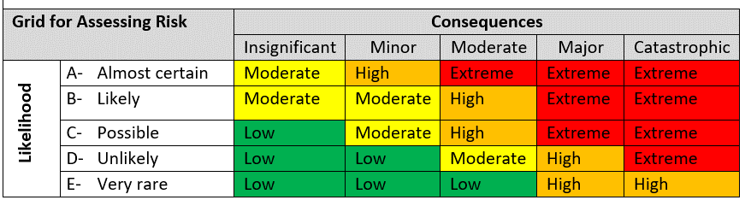

COMMUNICATION PLAN | Communication Plan Information
How will communication between the service and the child’s guardian/carer be facilitated moving forward?
Who will be the key points of contact regarding any further risk minimisation procedures?
Has the child’s guardian/carer been made aware all changes to the action plan need to be signed by a local doctor before being implemented?
Are all educators made aware in the induction process about the at- risk child and shown where action plan and medication including auto injection device is located?
Are all educators made aware of any changes with regards to the at-risk child. How?

FOOD ALLERGY ACTION PLAN - In the case of food allergies, select yes for each strategy that applies
Scenario | Strategy | Who | Yes/No
Food is provided by the children’s service and a food allergen is unable to be removed from the service’s menu (for example milk). | Menus are planned in conjunction with parents of at-risk child/ren and food is prepared according to parents’ instructions.  Email out menu to all parents for feedback.  Alternatively, the parent provides all of the food for the at-risk child, which is clearly labelled and stored in the kitchen. | Cook, Director and parent/carer | ☐Yes ☐No
 | Ensure separate storage of foods containing allergen. | Director and Cook | ☐Yes ☐No
 | Cook and staff observe food handling, preparation and serving practices to minimise the risk of cross contamination. This includes hygiene of surfaces in kitchen and children’s eating area, food utensils and containers. | Cook and Educators | ☐Yes ☐No
 | There is a system in place to ensure the at-risk child is served only the food prepared for him/her. This includes coloured bowls, etc. | Cook, Room Leaders  & Educators | ☐Yes ☐No
 | An at-risk child is served and consumes their food at a place considered to pose a low risk of contamination from allergens from another child’s food. This place is not separate from all children and allows social inclusion at mealtimes. | Educators | ☐Yes ☐No
 | Children are regularly reminded of the importance of no food sharing with the at-risk child. | Educators | ☐Yes ☐No
 | Children are supervised during eating. | Educators | ☐Yes ☐No
 | Add other if applicable: |  | ☐Yes ☐No
Party or celebration | Ensure the at-risk child only has the food approved by his/her parent/guardian. | Room Leaders | ☐Yes ☐No
Party or celebration | Any special treats are to be given wrapped up and sent home with the children. | Room Leaders Office Manager Director | ☐Yes ☐No
Party or celebration | Add other if applicable: |  | ☐Yes ☐No
Cooking with children | Ensure parents/ guardians of the at-risk child are advised well in advance and included in the planning process. Parents may prefer to provide the ingredients themselves. | Room Leaders | ☐Yes ☐No
Cooking with children | Add other if applicable: |  | ☐Yes ☐No

FURTHER COMENTS:

I agree that the service will respond as per attached individual action plan(s).
Guardian/Carer name:
Guardian/Carer signature: |  | Date:
Staff name:
Staff signature: |  | Date:

List all teachers/educators responsible for a child with a medical condition:

Name | Date | Position | Signature

ADDITIONAL NOTES

