

REYLL Reference R084.
This document is for use by registered REYLL participants only

Sensory Toolkit
Introduction | 4
Linking to the National Quality Standards | 5
Sustainability in practice | 6
Marbled oobleck | 7
Cloud dough | 8
Aromatherapy playdough | 9
Shredded paper construction | 10
Coloured water | 10
Frozen flowers | 11
Sponge, water and bubbles | 12
Mud and herb pies | 13
Glitter shaving foam | 14
Soap fluff | 15
Tractors in mud | 16
Ice blocks in water | 17
Squeezy balloons | 18
Paint bags | 18
Sand clay | 19
Moon sand | 20
Lavendar salt | 21
Salt dough | 22
Nature soup | 23
Rainbow ribbon | 24
Rainbow fabric scraps | 25
Pebble provocation | 26
Water feely bags | 27
Bubble wrap popping | 28
Rainbow tissue paper | 29
Textured feeling stones | 30
Textured stepping stones | 30
Heuristic play | 31
Musical instruments | 32
Sound bottles | 32
Calming music | 33
Sound matching game | 34
Contents
Listening walks | 35
Echo singing | 36
Song jar | 37
Clap and tap | 38
Light table with blocks | 39
Kaleidoscopes | 40
Colour mixing | 41
Sensory bottles | 42
Watch and copy movement games | 43
Mirror play | 44
Smelling jars | 45
Herbs and flowers sensory tray | 46
Scented paints | 47
Fabric soft scented toys | 48
Scented water | 49
Food tasting | 50
Taste test adventure | 51
Balance beam | 52
Obstacle course | 53
Dancing | 54
Pushing heavy blocks | 55
Tug of war | 56
Regulating breathing exercises | 57
Sources | 58
Contents
Introduction

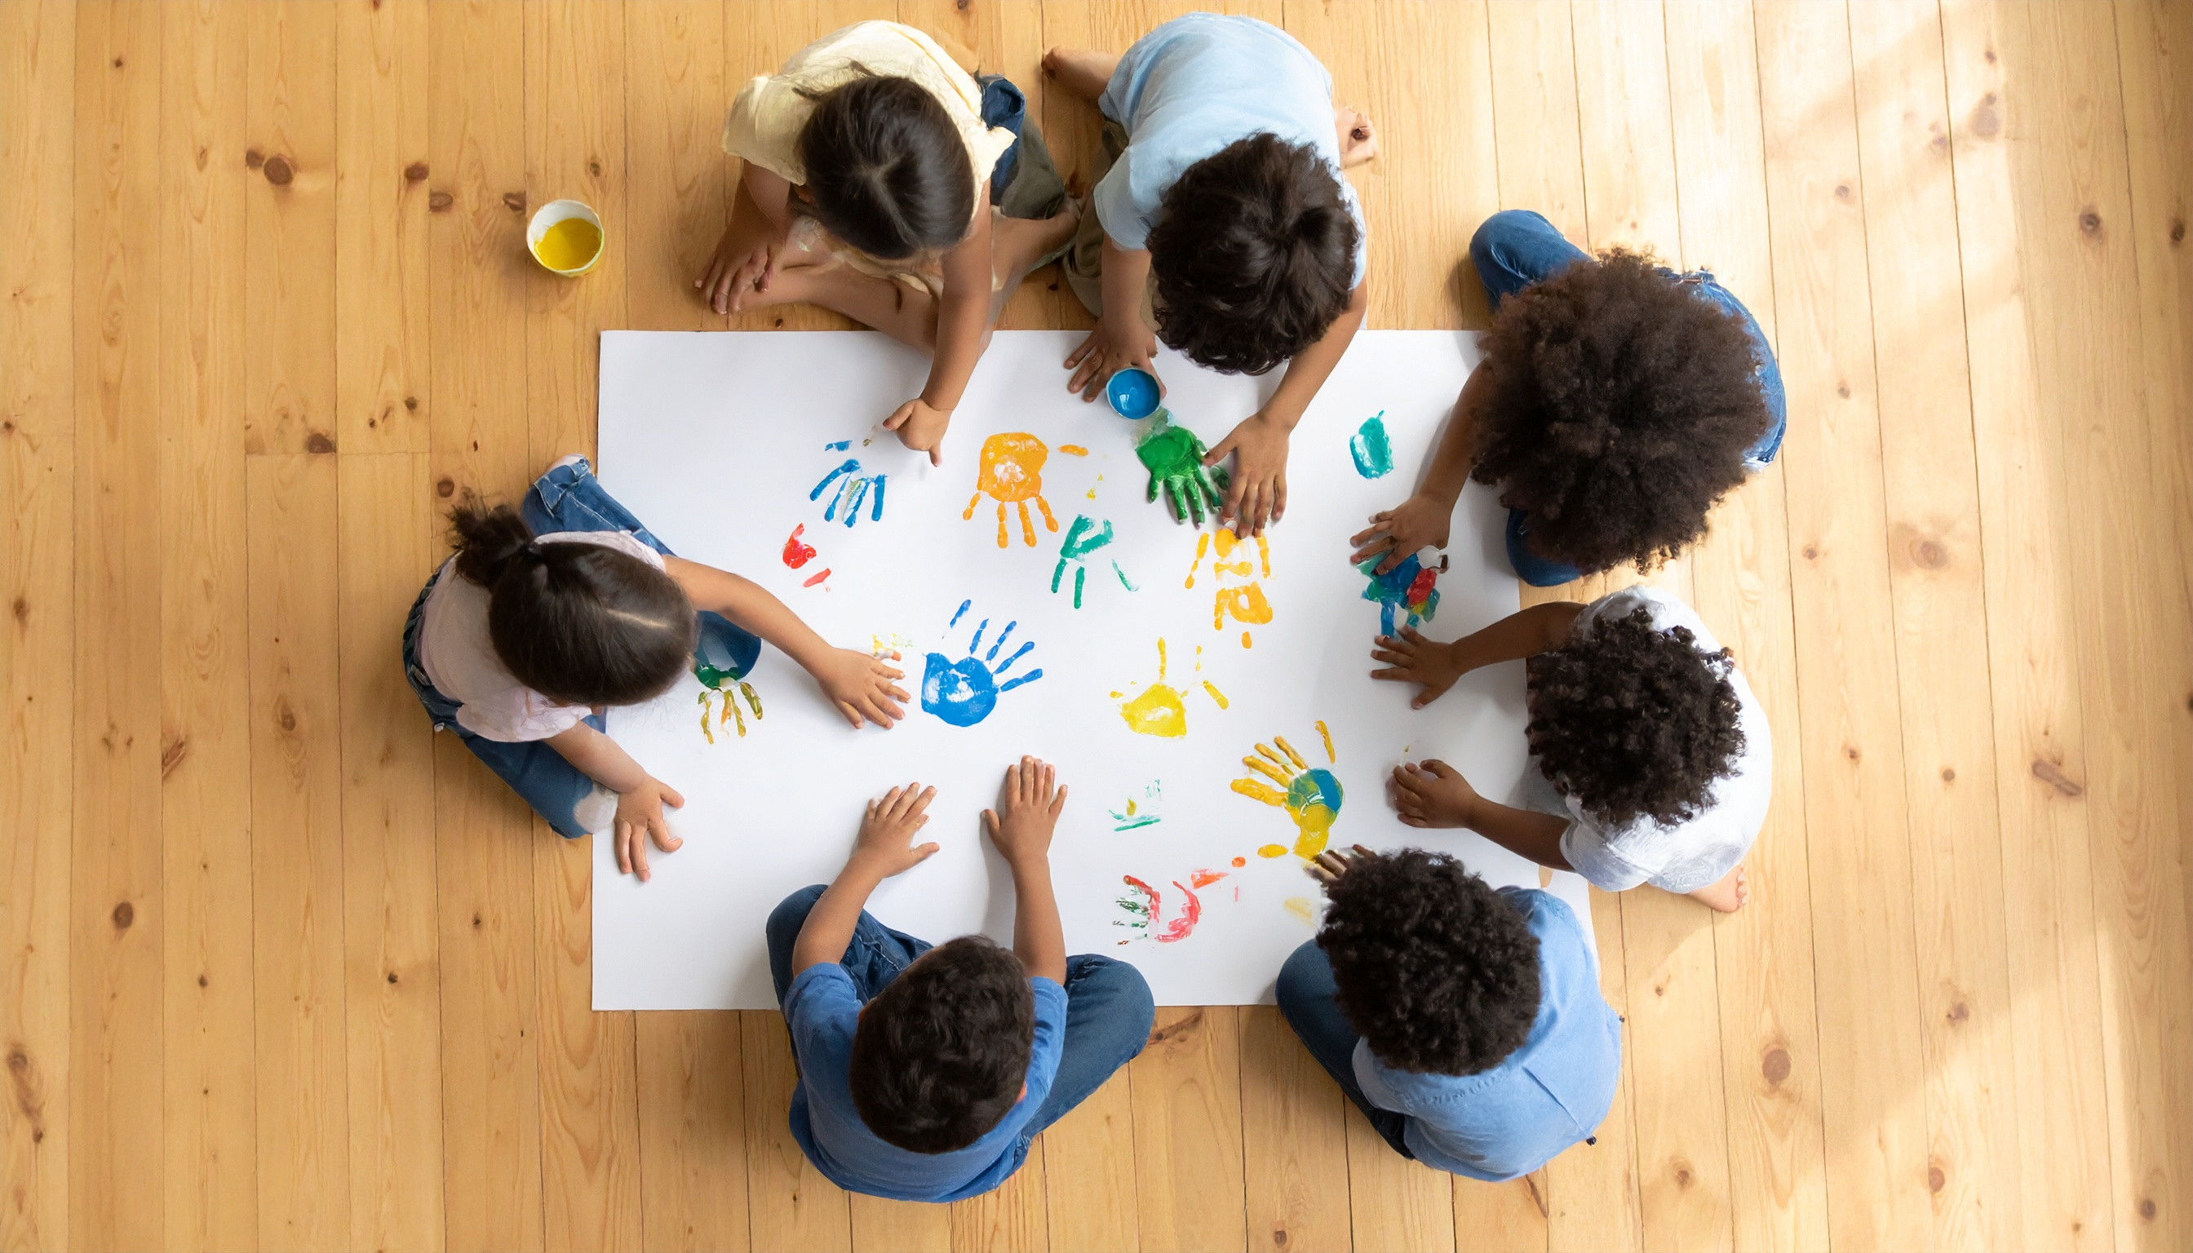
This practical and inspiring resource is designed to help adults plan and implement a wide variety of sensory experiences, tailored to meet the unique needs, interests, and developmental stages of all children.
Whether supporting sensory regulation, encouraging communication, or fostering creativity and curiosity, this guide offers ready-to-use ideas across all sensory domains.
With adaptable suggestions, inclusive strategies, and clear links to the EYLF and NQS, this resource empowers adults to create meaningful, engaging, and responsive sensory opportunities that promote wellbeing, inclusion, and a love of learning in every child.
Linking to the National Quality Standards
Sensory play in early childhood education and care settings engages more than just touch. This toolkit aims to help you implement a variety of experiences targeted to all the different senses. The following areas can be found within this toolkit:
- Tactile (touch)
- Auditory (listening)
- Visual (sight)
- Olfactory (smell)
- Gustatory (taste)
- Vestibular (movement & balance)
- Proprioceptive (body awareness)
Benefits of sensory play:
Sensory play provides children with opportunities to explore touch, sight, smell, sound, movement, and body awareness. Through these experiences, children notice changes in their bodies and feelings when interacting with different materials. Over time, they learn strategies to self-regulate, focus attention, or re-energise, supporting emotional regulation.

Australian professional guidance (see sources) recognises sensory play as an important part of supporting children’s wellbeing and learning. The Early Years Learning Framework (EYLF V2.0) highlights that wellbeing is central to learning and that children develop self-regulation through everyday experiences, supported by responsive adults. The ACECQA guides also emphasise that educators play a vital role in helping children manage emotions and behaviour while engaging in rich learning experiences.

In practice, sensory play has links strong to the National Quality Standard (NQS). It reflects Quality Area 1 through intentional planning of experiences, Quality Area 2 by supporting the children’s wellbeing and safety, Quality Area 3 by offering a sensory rich environment, and Quality Area 5 through educator-child relationships and co-regulation.

These practices sit under the National Quality Framework and align with the Education and Care Services National law and Regulations. By planning, supervising and reflecting on sensory play, educators are supporting children’s emotional development in ways that meet both regulatory requirements and best practice guidelines.

While sensory play is not explicitly mentioned in the NQS, it aligns with principes that support learning through play, physical and cognitive development, inclusive practice, and responsive environments. Activities in this toolkit highlight links to the EYLF and NQS to guide adults in planning, supervising, and reflecting on experiences that support children’s emotional development.

Sustainability in practice

The sensory experiences in this toolkit are designed to be flexible and adaptable, allowing adults to tailor activities to the unique needs of their children, the physical environment, and the resources they have available. Materials and steps can be adjusted to suit different spaces, group sizes, and developmental levels, ensuring that every child can fully engage with the experiences.
Where possible, adults are encouraged to source materials sustainably. This can include using natural, recycled, or repurposed items, or accessing specialist resource centres such as Remida Perth (WA), Reverse Garbage (NSW), Reverse Art Truck (VIC), and Urban Upcycle (VIC). These organisations collect and share clean, safe industry offcuts and materials that can be used for play and learning, reducing waste and support environmentally responsible practice.
This toolkit offers a collection of hands-on sensory experiences that can be adjusted to meet the needs of all learners. Each activity includes clear links to the National Quality Standards, supporting adults to provide rich, inclusive, and sustainable sensory play that nurtures curiosity, wellbeing, and a love of learning.
Most importantly this sensory toolkit is fun for children, educators and families!

Touch (tactile)

Marbled Oobleck
Resources:
2 cups of corn flour
2 cups of water
Food colouring or paint
Instructions:
Mix the ingredients together and pour into a large tray such as a tuff tray, making sure to spread it out to cover the entire surface.
Invite the children over to squeeze food colouring or paint over the top, before encouraging them to use their fingers to swirl it in.

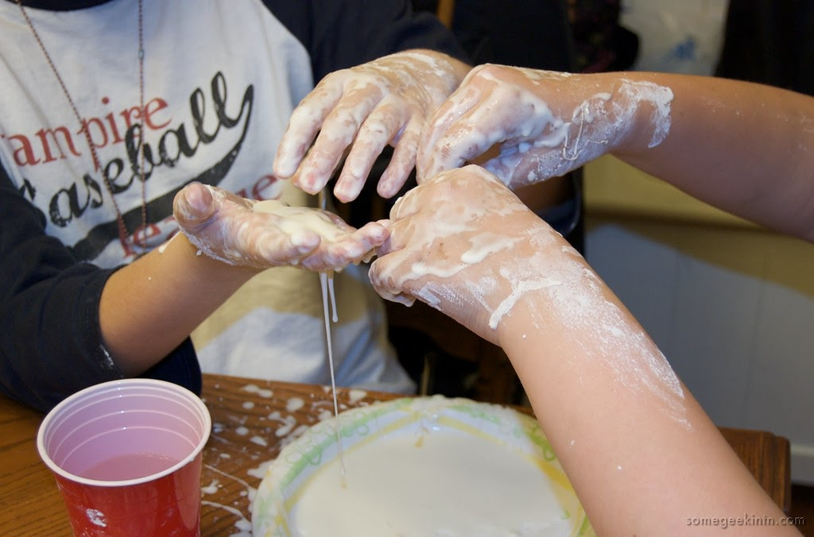
Links to NQS and EYLF:
NQS – Quality Area 1: Educational program and practice:
Oobleck provides an open-ended, play-based experience that supports exploration, problem-solving, and inquiry.

EYLF – Outcome 3: Children have a strong sense of wellbeing
Manipulating oobleck supports fine motor strength, coordination, and sensory regulation.
Notes:
If you have children who are hesitant to use their fingers, you can also use pop sticks or sticks to swirl the colours in.
Touch (tactile)
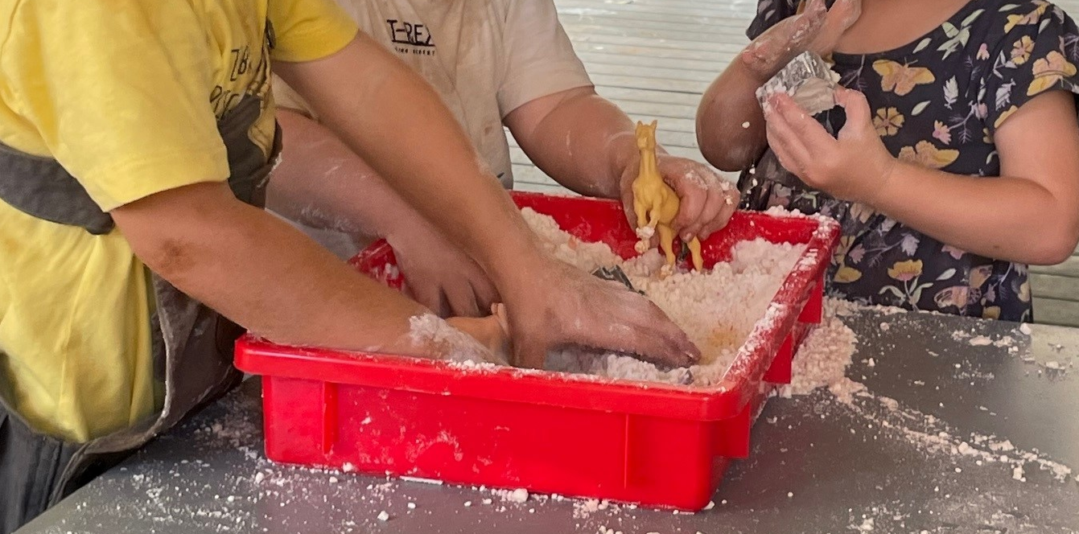
Cloud Dough
Resources:
1 cup vegetable oil
4-5 tbsp powder paint (optional)
6 cups flour
Instructions:
Mix the two ingredients together until they are combined forming a soft, crumbly, dough-like damp sand.
Add powder paint and mix thoroughly to colour it.

Links to NQS and EYLF:
NQS – Quality Area 2: Children’s health and safety:
Cloud dough provides a safe, supervised sensory outlet that can support emotional regulation.

EYLF – Outcome 4: Children are confident and involved learners
Promotes creativity and imagination when used in pretend play (e.g. ‘cakes or sandcastles’).
Notes:
To further enhance this experience and the children’s learning, bring in resources such as rolling pins, leaves, and sticks to press into the dough.
Touch (tactile)
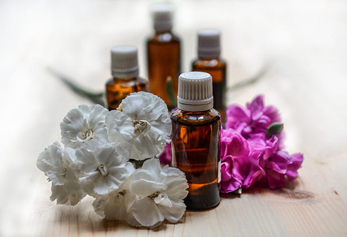
Aromatherapy playdough
Resources:
2 cups of plain flour
½ cup of salt
2 tbsp oil
2 tbs cream of tartar
1 cup boiling water
Food colouring
3-4 drops essential oils
Instructions:
Mix dry ingredients.
Add essential oil to the oil first, as this is a carrier oil – this is important for safety.
Add food colouring to boiling water.
Combine all the dry ingredients to the boiling water.
Knead until smooth and soft.
Safety Note:
As this experience uses boiling water, be mindful of the children and yourself and wait for it to be cool enough to knead without burning your own hands.

This experience also links to the sense of smell.
Notes:
The safest essential oils to use for children are lavender, lemon, orange, tea tree and chamomile.
To further extend children’s learning with this experience, consider adding natural loose parts to the dough such as twigs, bark leaves, pebbles, or shells to make beautiful works of art.
Links to NQS and EYLF:
NQS – Quality Area 3: Physical Environment
Aromatherapy playdough supports fine motor development through, rolling, squeezing and moulding playdough.

EYLF – Outcome 4: Children are confident and involved learners
Aromatherapy playdough supports children to strengthen their fine motor skills through manipulating, rolling, and shaping playdough.
Touch (tactile)

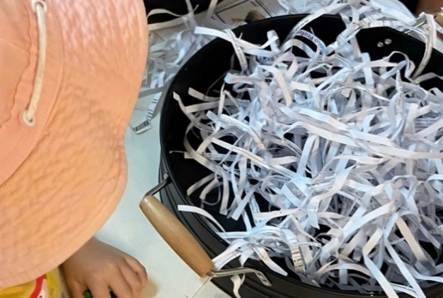
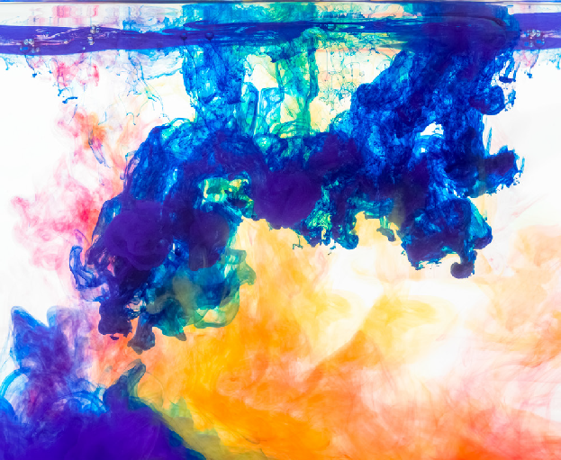
Shredded paper construction
Resources:
Shredded paper
Tub or box
Construction trucks
Instructions:
Put shredded paper into a tub or box.
Spread it out so that it covers the bottom completely.
Add construction trucks to the paper.

Notes:
This experience only takes a few seconds to set up. It can be extended by adding animals, numbers, letters, or small insect toys.
Links to NQS and EYLF:
NQS – Quality Area 6: Collaborative partnerships with families and communities
Families can contribute to recycled paper, teaching sustainability practices.

EYLF – Outcome 2: Children are connected with and contribute to their world
Shredded paper construction teaches children about environmental awareness through recycling and reusing materials.
Notes:
To further extend on the children’s learning add whisks, washing up liquid, plastic funnels etc. Encourage the children to explore capacity and colours, by mixing, filling and emptying containers and adding colours together.

Links to NQS and EYLF:
NQS – Quality Area 1: Educational program and practice
Coloured water supports open-ended exploration, experimentation, and problem-solving.

EYLF – Outcome 4: Children are confident and involved learners
Coloured water encourages scientific exploration with cause and effect, prediction, and experimentation with colour mixing.
Coloured water
Resources:
Water
Bottles or containers
Food colouring
Instructions:
Fill bottles ¾ full of water.
Add some food colouring to each container, mix to combine.
Set the bottles put in a large tray alongside some cups and bowls.

Touch (tactile)
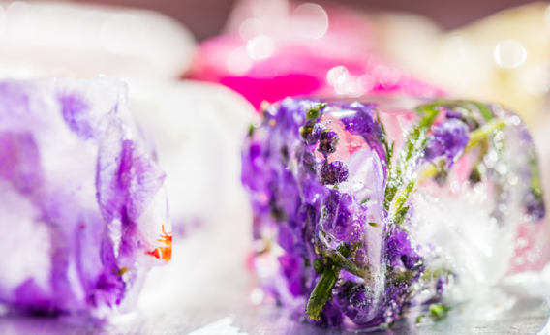
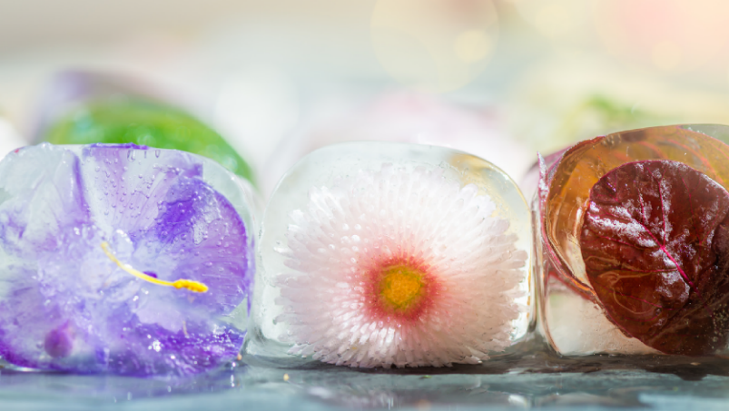
Frozen flowers
Resources:
Water
Small containers or balloons
Fresh flowers and leaves
Freezer space
Instructions:
Fill some containers or ballons with water ¾ of the way to the top.
Add some fresh flowers or leaves and submerge them as much as possible.
Top up the containers or balloons until they are full, then put them in the freezer until frozen.

Links to the NQS and EYLF:
NQS – Quality Area 1: Educational program and practice
This frozen flower experience supports open-ended exploration: children can observe, touch and experiment with melting ice and colours.

EYLF – Outcome 3: Children have a strong sense of wellbeing
Children are encouraged to strengthen their fine motor skills as they scrape, hold, or move the ice blocks around.

Notes:
To further extend the children’s learning place the frozen flowers into a tray with pipettes, syringes and warm water.
Safety Note:
When engaging in this experience, take note of the weather to see if it is suitable for ice play.

Touch (tactile)

Links to the NQS and EYLF:
NQS – Quality Area 1: Educational program and practice
This experience encourages open-ended, play-based learning where children explore water, bubbles and textures.

EYLF – Outcome 1: Children have a strong sense of identity
Children gain confidence and independence as they choose how to explore and manipulate the materials.

Notes:
Further extend this experience for the children by encouraging them to soak the water up in the sponges, by squeezing it, before emptying it into empty containers to fill them up. Also add some cars/trucks, dolls or animals and set it up as a washing station.

Safety Note:
Educators must always maintain the appropriate level of supervision around this experience.
Sponges, water and bubbles
Resources:
Cut up sponges in different sizes and thickness
Water
Sensitive skin bubble wash or washing up liquid
Small containers
Instructions:
Fill a tub with water.
Add the sponges and a small amount of washing up liquid.
Add some small containers as well.

Notes:
To further extend the children’s learning, ask them open-ended questions about what they are making with their mud. Engage in the experience with them to challenge their creativity.
Touch (tactile)
Links to the NQS and EYLF:
NQS – Quality Area 3: Physical environment
Mud play supports gross motor development (digging, squelching, carrying containers of mud) and fine motor skills (scooping, moulding, shaping).

EYLF – Outcome 2: Children are connected and contribute to their world
Mud play promotes connect to nature and understanding of the environment.
Mud and herb pies
Resources:
Flowers and leaves
Herbs
Grass
Mud
Water
Old kitchen utensils
Containers
Instructions:
Find a spot outside to set up a nature kitchen.
Use a table, upside down tub, or old chair as a base.
Add in the utensils and natural materials.
Let the children explore.

Touch (tactile)

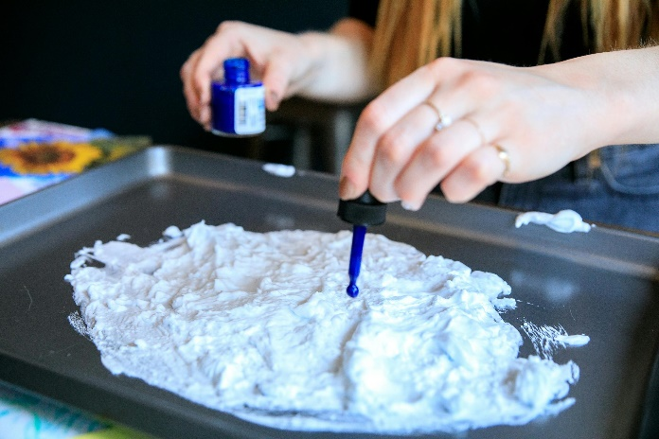
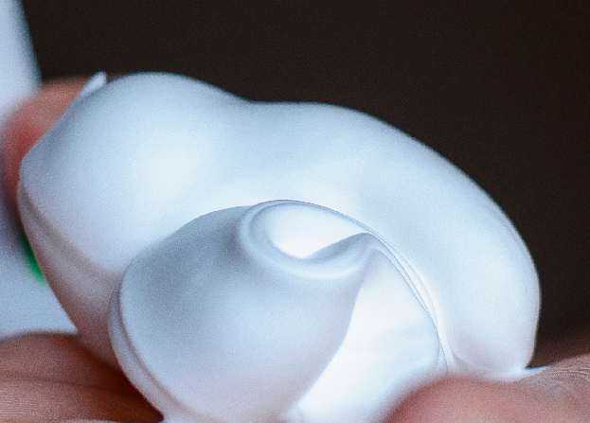
Links to NQS and EYLF:
NQS – Quality Area 5: Relationships with children
Shaving foam experiences encourage collaborative play and social interactions, as the children share materials and communicate with one another.

EYLF – Outcome 2: Children are connected and contribute to their world
Group play supports the development of cooperation, as children practice sharing and turn-taking while working alongside others.
Safety Note:
Please make sure this experience promotes the safety of all children at all times.
Notes:
Make sure to have water and a towel ready to go for cleanup as this experience can get messy.
Glitter shaving foam
Resources:
1-2 Shaving foam
Glitter or confetti
Large tray or container
Food colouring (optional)
Instructions:
Squirt all the shaving foam onto a tray.
Sprinkle glitter or confetti over the shaving foam and mix it in with hands.
Add food colouring in and mix.

Touch (tactile)
Safety Note:
Make sure the children avoid wiping their eyes during this experience.
Links to the NQS and EYLF:
NQS – Quality Area 1: Educational program and practice
- While engaging in this experience, children experiment with textures and materials while developing fine motor skills through tearing, mixing, and squishing.
EYLF – Outcome 3: Children have a strong sense of wellbeing
- Soap fluff provides a regulating, tactile experience that supports self-regulation and fine motor development.

Soap fluff
Resources:
Large bag of cotton balls/pads
2-3 cans of shaving foam
Confetti or biodegradable glitter
Container

Instructions:
Ask the children to tear apart the cotton pads layer by layer and to add them into a sensory tub.
Squirt the shaving foam all over the top and mix it all together.
Sprinkle confetti glitter over top for extra sensory sparkle.

Note:
Have water and a towel ready to go for the children to wash their hands on once done.

Touch (tactile)

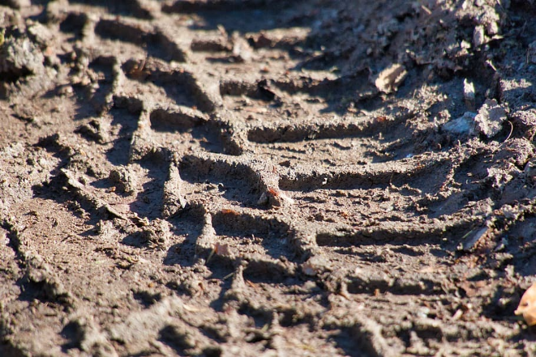
Tractors in mud
Resources:
Tractors
Dirt
Water
Large container

Instructions:
Find a spot to set up the experience.
Add dirt and water to the tub and mix together to make mud.
Place tractors in the mud.

Links to the NQS and EYLF:
NQS – Quality Area 3: Physical environment
Mud play supports gross motor development (digging, squelching, carrying containers of mud) and fine motor skills (scooping, moulding, shaping).

EYLF – Outcome 2: Children are connected and contribute to their world
Mud play promotes connect to nature and understanding of the environment.

Notes:
As this experience can get messy, make sure to have water and a towel ready to go.
To further extend on this experience, add animals to the mud to make a farm sensory experience.
Touch (tactile)

Ice blocks in water
Resources:
Ice cubes
Food colouring
Water
Scoops

Instructions:
Fill ice cube tray with water and small amount of food colouring.
Freeze the ice cubes.
Once fully frozen, tip out the ice cubes into a tub of water.

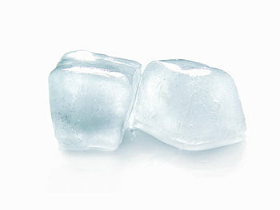
Links to the NQS and EYLF:
NQS – Quality Area 1: Educational program and practice
This ice blocks in water experience supports open-ended exploration: children can observe, touch and experiment with melting ice and colours.

EYLF – Outcome 3: Children have a strong sense of wellbeing
Children are encouraged to strengthen their fine motor skills as they scrape, hold, or move the ice blocks around.
Notes:
To further extend on the children’s learning, add scoops and nets to the floating ice cube tub to encourage the children to play a fishing game. You can also add sea animals to create a scene for imaginative play. Other items to can also be added to the ice to for other experiences.
Safety Note:
When engaging in this experience, take note of the weather to see if it is suitable for ice play.
Touch (tactile)
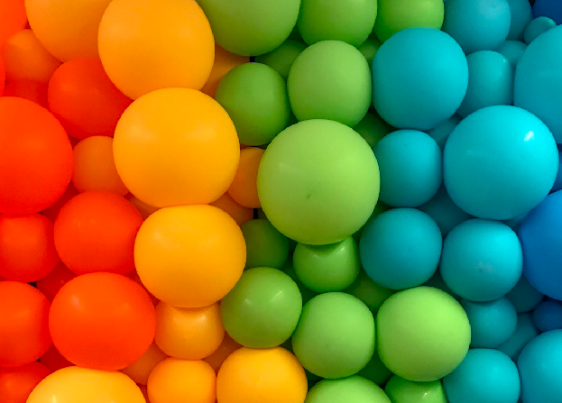
Notes:
This experience can be further extended for the children by adding two colours to one bag and encouraging them to mix them together. Or by adding glitter to the paint.
Links to NQS and EYLF:
NQS – Quality Area 1: Educational program and practice
Paint bags provide open-ended, play-based learning as children explore colour, shape, and movement.

EYLF – Outcome 3: Children have a strong sense of wellbeing
Pressing and spreading paint supports fine motor skills, hand strength and sensory regulation.
Paint bags
Resources:
Ziploc bags
Washable paint
Tape (optional)
Instructions:
Squeeze paint into a Ziploc bag.
Seal the bag tightly.
Place the bag on the table or floor tape it to a window or door.

Links to the NQS and EYLF:
NQS – Quality Area 2: Children’s health and safety
Squeezy balloons provide a safe and calming sensory outlet to help children self-regulate emotions such as stress or frustration.

EYLF – Outcome 3: Children have a strong sense of wellbeing
This experience promotes emotional regulation and stress relief.
Notes:
Stretching balloons can also be used for testing children’s strength as well as for releasing stress and anxiety.
Supervise balloon activities at all times.

Squeezy balloons
Resources:
1 cup of cornflour
½ cup hair conditioner
Balloons
Instructions:
Mix cornflour and conditioner together until mixed well, it should be stretchy and soft.
Break into small pieces and push into the balloon.
Fill them to fist size.
Squeeze out extra air and tie off.

Touch (tactile)
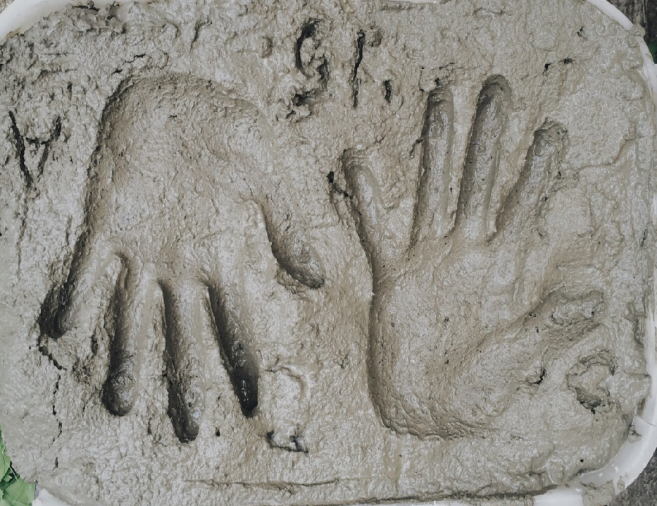
Links to NQS and EYLF:
NQS – Quality Area 1: Educational program and practice
Educators can scaffold the children’s learning through discussion of textures (wet/dry, soft/hard), and concepts like measurements or shape.

EYLF – Outcome 2: Children are connected and contribute with their world
Sand clay can include natural materials to embed sustainability and connection to nature.

Sand Clay
Resources:
2 cups sand
1 ½ cups plain flour
1 cup warm water
1 ¼ cups salt
Shells

Instructions:
Mix together sand, flour and salt in a large bowl.
Slowly add in warm water, mix with a large spoon as you go.
Knead the dough on a lightly floured surface until stretchy and soft like playdough.

Notes:
Add the water carefully and just balance it out. If it feels too sticky add more flour or sand.
This experience can be used to make models or sculptures. This experience can also be used to make keepsakes of children’s hands or feet, by rolling it out into small discs and pressing the children’s hands or feet into the clay. Bake on baking paper in the oven at 120 degrees for 3-4 hours turning once.

Touch (tactile)

Moon sand
Resources:
4 cups of play sand
2 cups of corn flour
1 cup water
4 tbsp powder paint (optional)

Instructions:
Mix sand and corn flour into a large bowl until combined.
Tip water in slowly, mixing as you go, until well combined, and the consistency resembles a crumbly pastry mix.
If it doesn’t hold together when formed in a ball, add a small amount of water until it feels right.
It shouldn’t feel wet, just a little bit damp.
If adding powder paint, add it now and mix thoroughly.

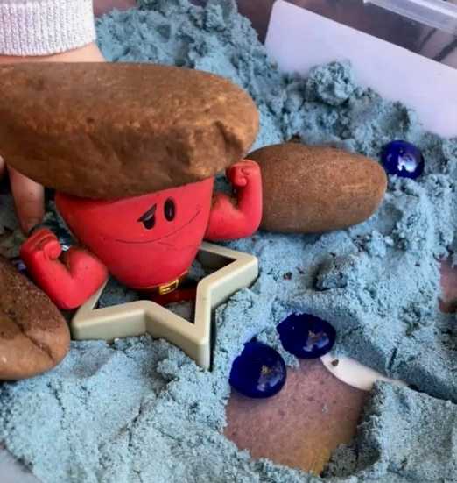
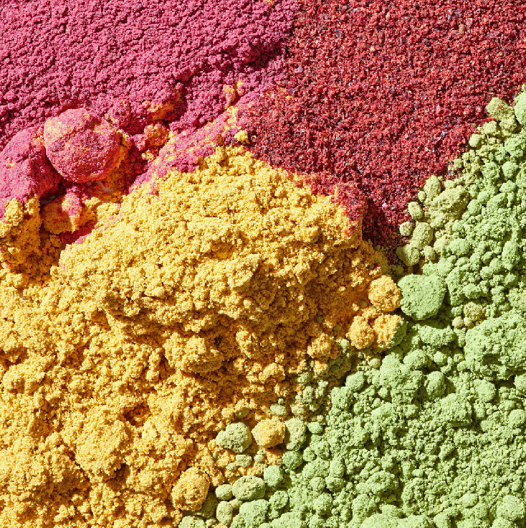
Links to NQS and EYLF:
NQS – Quality Area 1: Educational program and practice
Moon sand provides an open-ended, play-based experience that promotes exploration, creativity and problem-solving.

EYLF – Outcome 1: Children have a strong sense of identity
This experience promotes independence of a child as they choose how to shape, mould, and create with the sand
Notes:
Moon sand holds it shape well. To further extend on the children’s learning, add cookie cutters, sand moulds and silicone cupcake, or muffin tins.

Touch (tactile)

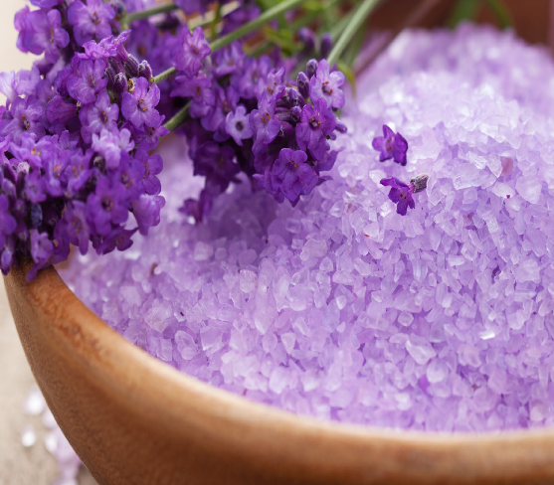
Notes:
To further extend this experience, spread the lavender salt onto a tray to make a mini–Zen Garden, add a tiny rake (or fork) for children to create patterns with.

Lavender salt
Resources:
1 cup of salt
Few drops of purple paint or food colouring
2 drops of lavender essential oil
Or 2-3 heads of crushed fresh lavender

Instructions:
Tip the salt into a Ziploc bag and add the food colouring.
Seal the top of the bag shut and shake the bag or use your hands to mix the colour through the salt until it is all combined.
Add lavender to the salt and mix again.
Tip onto a tray and leave it to dry.

Links to the NQS and EYLF:
NQS – Quality Area 2: Children’s health and safety
The scent of lavender can have a soothing and regulating effect, this supports children’s emotional wellbeing.

EYLF – Outcome 3: Children have a strong sense of wellbeing
Lavender’s calming properties support emotional regulation and relaxation.
This experience also links to the sense of smell.
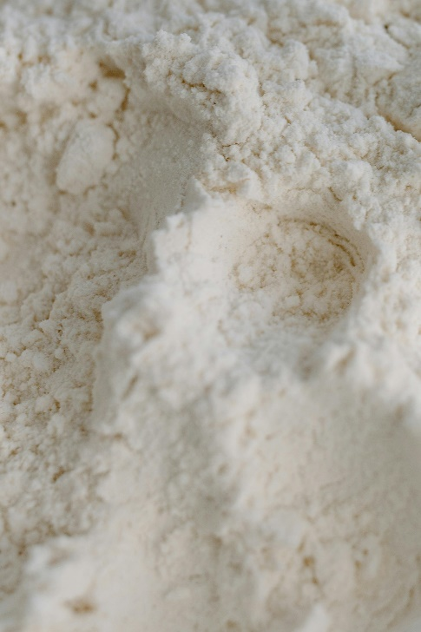
Salt dough
Resources:
1 cup of salt
Few drops of purple paint or food colouring
2 drops of lavender essential oil
Or 2-3 heads of crushed fresh lavender

Instructions:
Tip the salt into a Ziploc bag and add the food colouring.
Seal the top of the bag shut and shake the bag or use your hands to mix the colour through the salt until it is all combined.
Add lavender to the salt and mix again.
Tip onto a tray and leave it to dry.

Touch (tactile)
Links to the NQS and EYLF:
NQS – Quality Area 5: Relationships with children
Working with salt dough encourages collaboration, conversation, and shared creativity between children and educators.

EYLF – Outcome 3: Children have a strong sense of wellbeing
Rolling, squeezing, and shaping dough helps build fine motor skills and coordination.

Notes:
Add rolling pins and cutters so that children can roll, mould or create small keepsakes. Leave the creations to air dry or bake in the oven at 160 degrees for 30 minutes, depending on the size of the creation.

Touch (tactile)

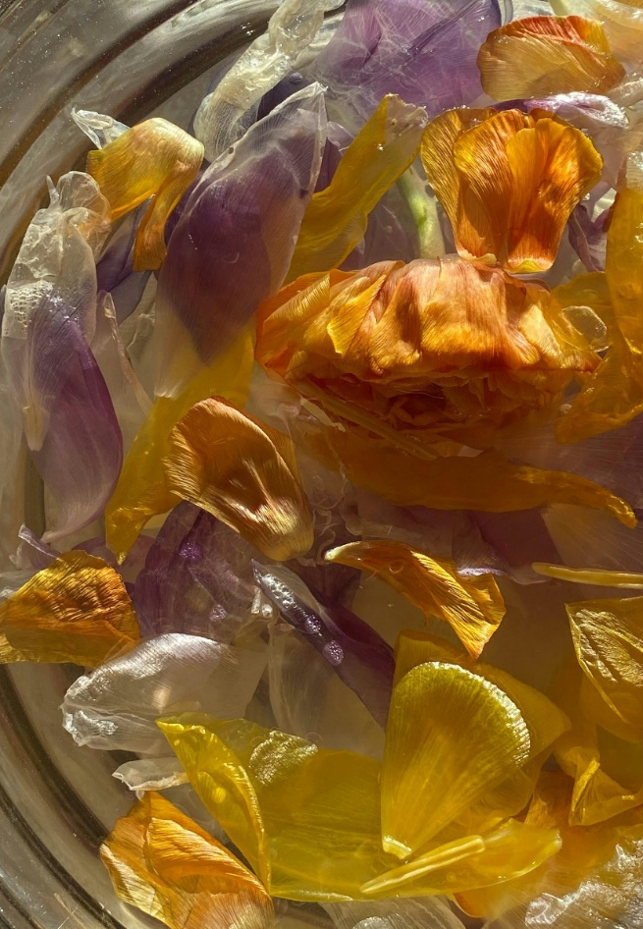
Nature soup
Resources:
Petals, leaves, bark, herbs, and other natural resources
Water
Bowls
Ladle and cups
Jars or bottles with lids

Instructions:
Take baskets or paper bags and encourage the children to join you on a nature hunt around the yard.
Find as many natural materials as possible.
Set out the items on a table or in a sensory tub with the bowls.
Add jugs of water and natural materials.

Link to NQS and EYLF:
NQS – Quality Area 1: Educational program and practice
Nature soup provides open-ended, play-based learning that encourages imaginative play, problem-solving, and exploration.

EYLF – Outcome 1: Children have a strong sense of identity
This experience builds confidence and self-expression as children create their own ‘recipes and imaginative scenarios.
Notes:
To further extend on the experience and the children’s imaginative skills, have them mix up ‘potions’ or ‘soups’ using the water, and natural resources found. Add in jasmine or lavender to add a scent to the experience. This can encourage talk on the smells, and the textures.
Touch (tactile)
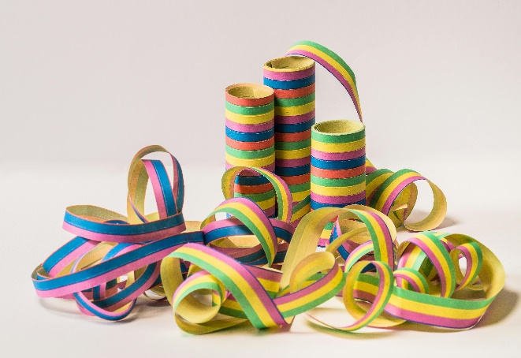
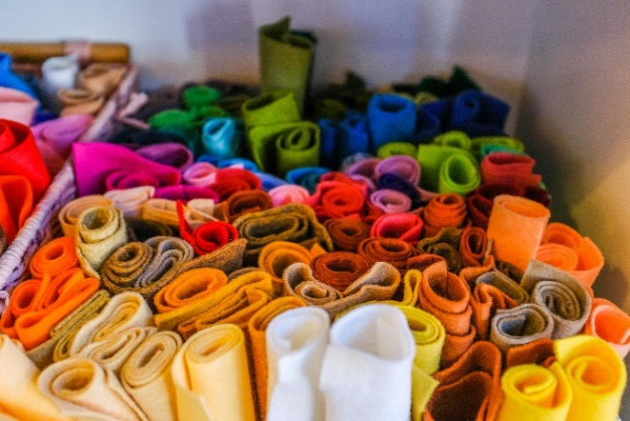
Rainbow Ribbon
Resources:
Ribbons in a variety of colours and lengths
Scissors (for educators only)
Sensory tub, basket, or tray

Instructions:
Cut the ribbons into different lengths and place them into a sensory tub or basket.
Invite the children to explore the ribbons
Encourage them to use the ribbons in imaginative play or movement games.

Notes:
To further extend on this experience, the ribbons can be attached to sticks to create ribbon wands.

Links to NQS and EYLF:
NQS – Quality Area 3: Physical environment
Rainbow ribbon provides an engaging and visually stimulating space that encourages movement and exploration.

EYLF – Outcome 3: Children have a strong sense of wellbeing
This rainbow ribbon experience strengthens gross motor skills, coordination, and body awareness through movement and dance.
Links to NQS and EYLF:
NQS – Quality Area 1: Educational program and practice
Rainbow fabric scraps promote hands-on, play-based learning experiences that support exploration, creativity, and sensory development.
EYLF - Outcome 4: Children are confident and involved learners
This experience supports problem-solving, sorting, and classifying skills through tactile investigation and imaginative thinking.

Rainbow fabric scraps
Resources:
A range of fabric scraps in different colours, textures, and sizes
Basket or sensory tub

Instructions:
Gather a collection of fabric scraps in a variety of colours and textures.
Place the scraps into a sensory tub or basket for children to explore.
Encourage the children to feel each fabric, compare textures, and sort them.
Notes:
This experience can be extended by adding water. Fill up a sensory tub with water and then add the fabric scraps into the water. Be sure to maintain supervision around the any water container.
Touch (tactile)
Touch (tactile)

Pebble provocation
Resources:
Pebbles or small rocks
Container
Bowls, scoops, spoons, and funnels
Small containers, jars or cups

Instructions:
Place the pebbles into a sensory tub.
Add scoops, tongs, and small containers for sorting, pouring and transferring.

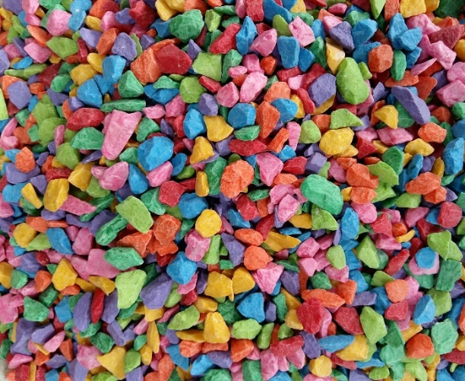

Notes:
This experience can be extended by adding natural loose parts, such as wooden discs, pinecones, or shells.
Links to the NQS and EYLF:
NQS – Quality Area 1: Educational program and practice
Pebble provocation play encourages children to explore and experiment as they scoop, pour and sort the pebbles.

EYLF – Outcome 4: Children are confident and involved learners
This experience promotes experimentation, and persistence as children test out new ways of using pebbles.

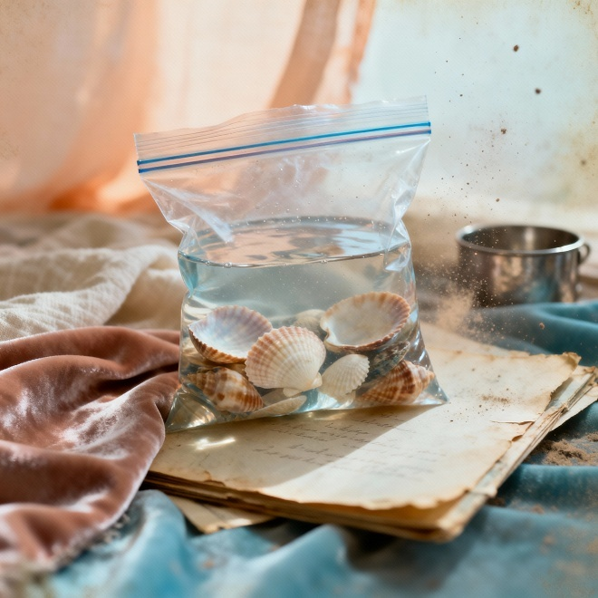
Notes:
This experience can be extended by adding natural loose parts, such as wooden discs, pinecones, or shells.
Touch (tactile)
Links to the NQS and EYLF:
NQS – Quality Area 3: Physical environment
The materials used for this experience create a safe and engaging space that invites sensory exploration and discovery by the children.

EYLF – Outcome 3: Children have a strong sense of wellbeing
Pressing, squeezing, and moving objects inside the bags supports fine motor skills and provides a calming sensory input.
Water feely bags
Resources:
Ziploc bags (strong, good quality)
Water
Small objects to add into the bags (shells, pom-poms, glitter, foam shapes)
Tape

Instructions:
Fill each Ziploc bag halfway with water.
Add different small objects to each bag.
Seal tightly (tape the seal for extra security).
Place the bags on a flat surface or tape them to the floor a window or table for exploration.
Touch (tactile)

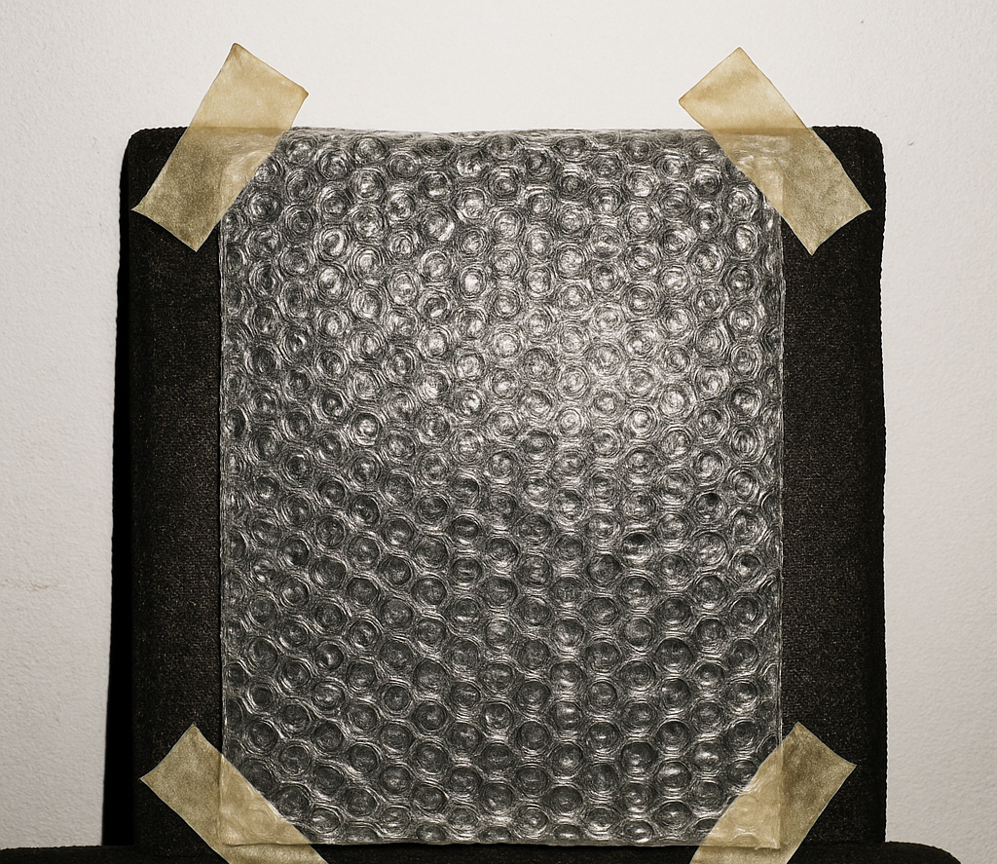
Bubble wrap popping
Resources:
Bubble wrap sheets (various sizes if available)
Tape (optional)

Instructions:
Spread bubble wrap on a flat surface, securing it with tape if needed.
Invite children over to pop and feel the bubble wrap.

Notes:
This experience can be extended by adding paint to the bubble wrap and having the children stamp it onto paper. Ensure close supervision when using soft plastic materials.
Links NQS and EYLF:
NQS – Quality Area 1: Educational program and practice
Bubble wrap popping provides open-ended, play-based learning as children explore sound, touch and movement.

EYLF – Outcome 1: Children have a strong sense of wellbeing
Children can make choices and take risks confidently as they interact with the bubble wrap.
Touch (tactile)

Rainbow tissue paper
Resources:
Coloured tissue paper
Small container or trays
Spray bottles with water
White paper or cardboard

Instructions:
Tear the coloured paper into small pieces and sort them by colour into containers.
Invite the children to place the tissue paper onto the white paper or cardboard.
Using the spray bottles encourage the children to lightly spray the tissue paper with water.
Once dry peel off the tissue paper to reveal the colourful patterns left behind.

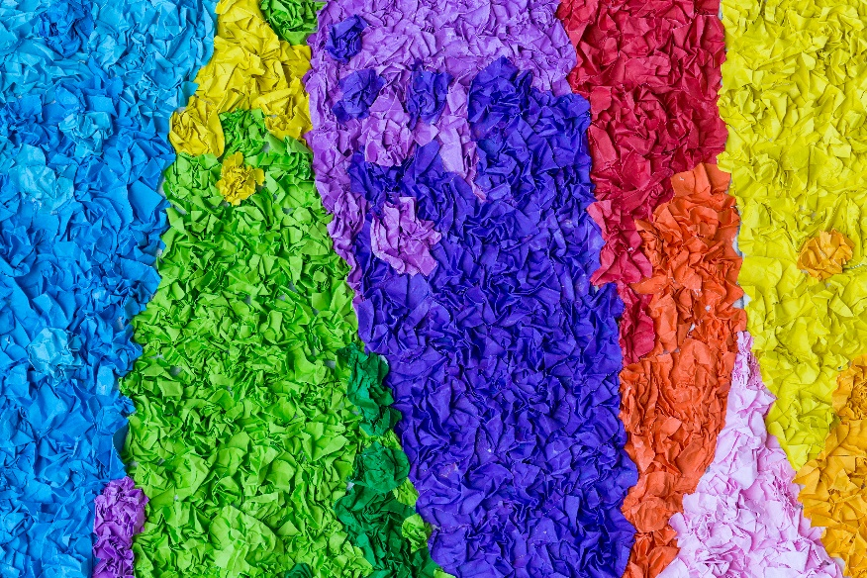

Links to NQS and EYLF:
NQS – Quality Area 3: Physical environment
This experience provides a stimulating and engaging learning space that supports discovery and artistic expression.

EYLF – Outcome 4: Children are confident and involved learners
This experience strengthens problem-solving and investigation skills as children explore how colours change and mix.

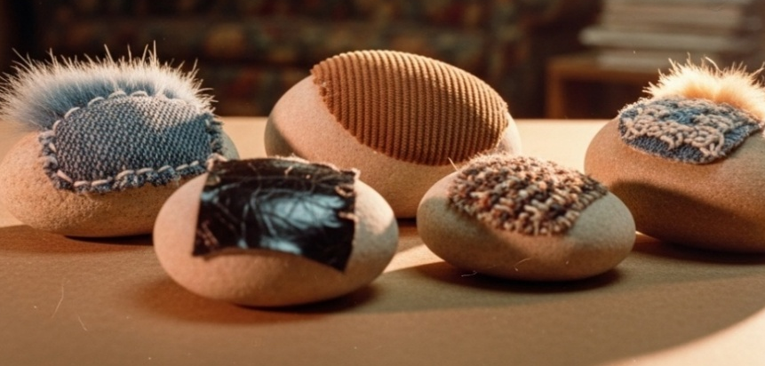
Textured feeling stones
Resources:
Medium-sized pebbles
Variety of textured materials (fabric scraps, fur, bubble wrap, carpet samples)
Strong glue or adhesive
Trays (optional)

Instructions:
Attach the different textured materials to the stones using the adhesive of your choice.
Allow glue to dry completely before use.
Place stones on a flat surface or the tray.

Touch (tactile)
Notes:
To further extend on this experience, introduce challenges to the children of only stepping on certain textures.
Textured stepping stones
Resources:
Cardboard cutouts
Variety of textured materials (fake grass, fur, bubble wrap, fabric scraps, foam, old pool cover samples)
Glue or tape
Non-slip mat (optional)

Instructions:
Cut cardboard into stepping-stone shapes.
Attach the different materials onto the cardboard using the glue or tape.
If using non-slip mats, stick them to the bottom of the cardboard.

Links to NQS and EYLF:
NQS – Quality Area 1: Educational program and practice
Textured stepping stones provide open-ended, play-based learning as children explore touch, balance and movement.

EYLF – Outcome 4: Children are confident and involved learners
Children are able to experiment with movement and problem-solving as they navigate the different stones.

Links to NQS and EYLF:
NQS – Quality Area 5: Relationships with children
Children can share, compare, and discuss textures with other children and the educators.
EYLF – Outcome 3: Children have a strong sense of wellbeing
Handling and exploring the textured stones builds on fine motor skills, and hand-eye coordination.

Notes:
To extend on this experience with the children, have the children sort the stones in size order, or grouped by texture.
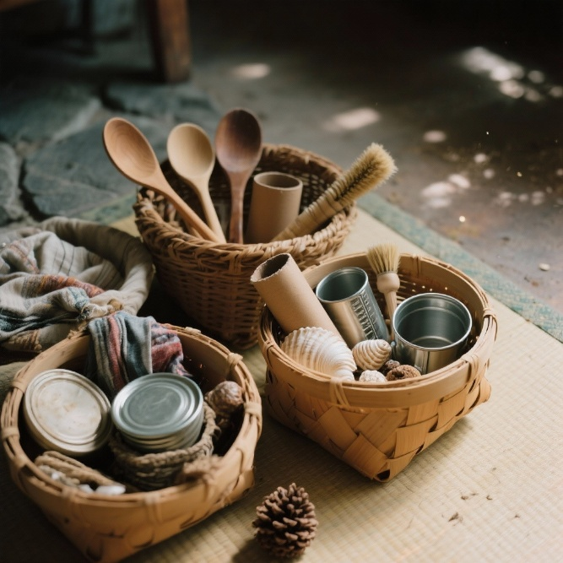
Safety note:
Ensure all materials are safe, clean, and age appropriate, avoiding small parts that could pose a choking hazard.
Heuristic Play
Resources:
A collection of safe, everyday objects made from a variety of materials
Baskets, trays, or tubs for sorting and storing
Clear floor space

Examples of materials:
Wooden spoons, metal lids, cardboard tubes, measuring cups, scarves, shells, curtain rings, jar lids, brushes, pinecones, and ribbon reels.

Instructions:
Set up an inviting play space with baskets or tubs filled with a variety of loose parts and everyday items.
Allow children to explore freely, handling, banging, rolling, stacking, filling, and emptying objects at their own pace.
Avoid demonstrating how to use objects, instead, observe the children’s natural curiosity and interactions.

Notes:
Heuristic play supports independent discovery, curiosity, and concentration. It provides opportunities for children to test ideas, explore cause and effect, and develop problem-solving and motor skills.
Touch (tactile)
Links to NQS and EYLF:
NQS – Quality Area 3: Physical environment
Heuristic play provides a rich and stimulating environment using natural, sustainable and open-ended materials.

EYLF – Outcome 2: Children are connected with and contribute to their world
When heuristic materials are sourced from recycled, natural, or repurposed objects, children begin to understand the concept of reusing and caring for the environment.
Sound (auditory)

Musical instruments
Resources:
Musical instruments
Basket

Instructions:
Have the children gather around either in a circle or as a group.
Hand out musical instruments to the children.
Encourage them to play them how they want to.
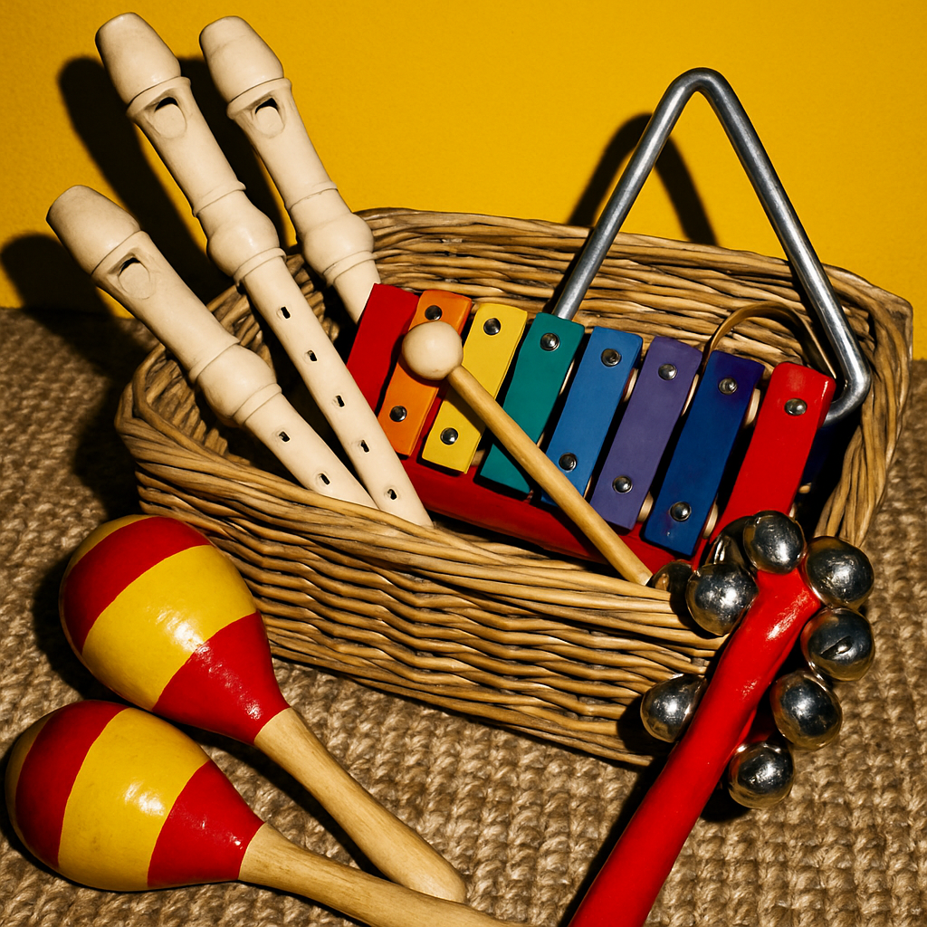

Sound bottles
Resources:
Empty water bottles
Rice
Macaroni pasta
Ribbons
Pom poms
Glitter
Sequins
Tape or glue

Instructions:
Fill the empty water bottles ¾ to halfway with the various resources.
Close the lid and seal it with glue or tape the lid shut.

Links to NQS and EYLF:
NQS – Quality Area 3: Physical environment
The use of instruments creates an engaging sensory-rich environment that encourages creativity and exploration.

EYLF – Outcome 3: Children have a strong sense of wellbeing
Music supports sensory regulation, emotional expression and self-soothing.
Notes:
This resource is a great addition to a calming corner within the environment.
Links to NQS and EYLF:
NQS – Quality Area 5: Relationships with children
Children can share discoveries, play together, and enjoy making music with peers.

EYLF – Outcome 4: Children are confident and involved learners
Children investigate, experiment and problem-solve as they test how different resources change the sound.

Notes:
This experience can be further extended by having nursery rhymes playing as well and role-modelling tapping or playing the instruments to the beat.
Sound (auditory)
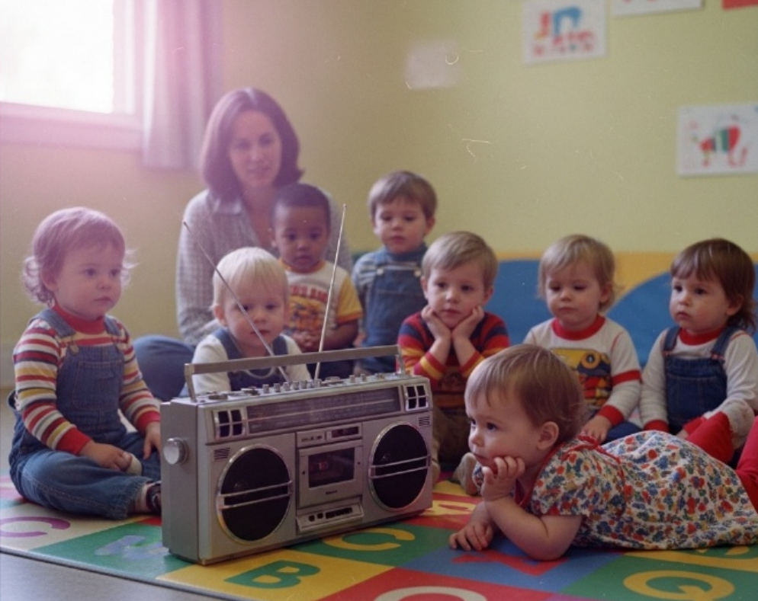
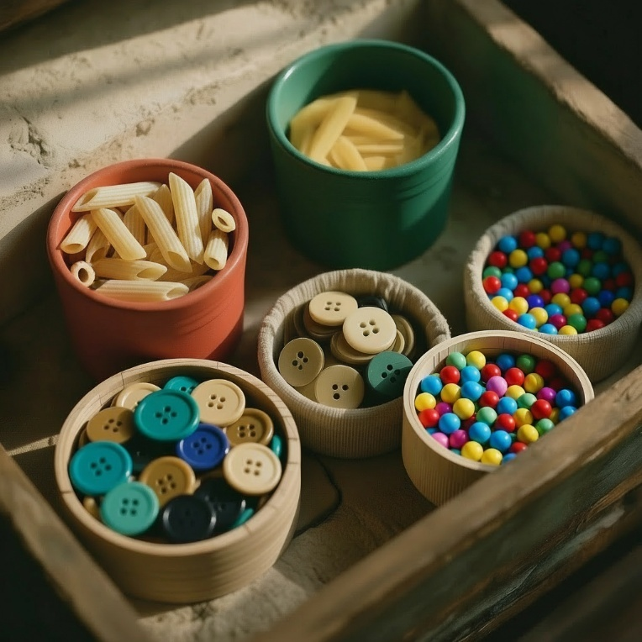
Calming music
Resources:
Speaker
Service approved device (if available)

Instructions:
Have the children gather around on the mat in a group.
Play some soothing classical, or piano music for the children and encourage them to listen.
Links to NQS and EYLF:
NQS – Quality Area 2: Children’s health and Safety
Music supports children’s emotional wellbeing, helping them to self-regulate and feel safe in their environment.

EYLF – Outcome 3: Children have a strong sense of wellbeing
Music helps children manage emotions, regulate their bodies, and develop relaxation strategies.

Links to NQS and EYLF:
NQS – Quality Area 3: Physical environment
This experience offers safe, engaging materials that promote sensory discovery through hearing.

EYLF – Outcome 4: Children are confident and involved learners
Children investigate, experiment, and problem-solve as they listen and match sounds.

Sound-matching game
Resources:
Small non-see-through containers
A variety of resources that make loud sounds (rice, pasta, beads, coins, bells, sand, buttons)
Tape or glue

Instructions:
Fill pairs of the containers with the same materials (e.g. two with rice, two with sand, etc).
Seal each container shut so children cannot see what is inside.
Place all containers in a basket or on a tray.
Invite children over to listen to the sounds to see if they can match them up.
Sound (auditory)
Notes:
This experience can be further extended by having the children guess what the resource inside the container is.
Sound (auditory)

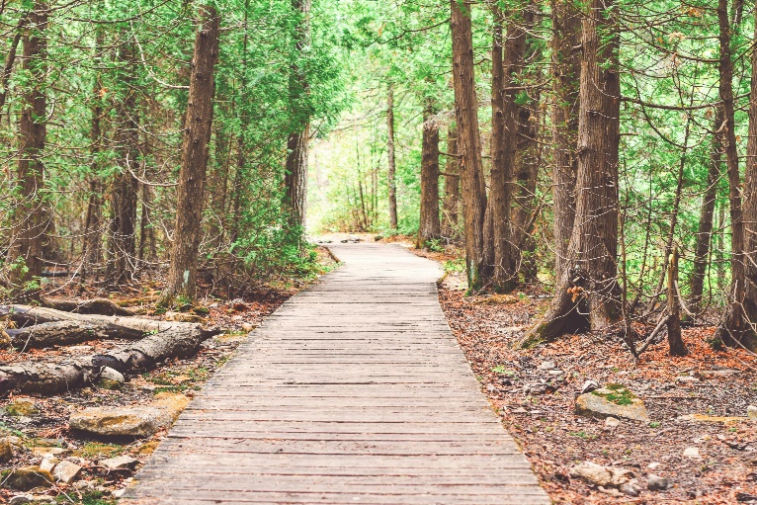
Listening walks
Resources:
A safe outdoor area to walk through
Clipboards
Paper
Pencils

Instructions:
Gather the children and explain that you are going on a walk to use their ears and listen carefully.
Encourage children to walk quietly and pay attention to the sounds around them (birds, cars, wind, footsteps, voices).
Pause often to listen and talk about what sounds are being noticed.
Ask the children to record sounds through drawings, marks, or symbols.

Safety notes:
If taking the children off site, please make sure you are following R014 Safe Transportation of Children Policy, R016 Excursion policy and R012 Excursion and Transport Authorisation Letter.

Links to NQS and EYLF:
NQS – Quality Area 1: Educational program and practice
Listening walks provide open-ended, play-based learning as children explore their environment through sound.

EYLF – Outcome 4: Children are confident and involved learners
Through nature walks children are encouraged to investigate, observe, and reflect as they identify and compare different sounds.

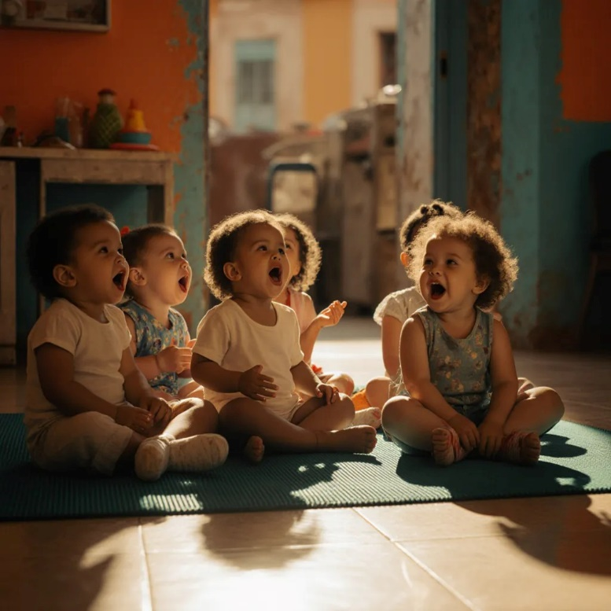
Echo singing
Resources:
A quiet space
Simple instruments or props (optional)

Instructions:
Sing or chant a short phrase, sound, or song line.
Encourage the children to listen carefully and then repeat what they heard.
Notes:
Echo singing can be adapted for different ages. Younger children can echo simple sounds (e.g. “la, la, la”), while older children may enjoy echoing full song lines or rhymes.
Sound (auditory)
Links to NQS and EYLF:
NQS – Quality Area 5: Relationships with children
This experience promotes turn-taking, active listening, and positive group interactions.

EYLF – Outcome 1: Children have a strong sense of identity
Children build confidence and a sense of belonging as they participate in group singing and taking turns.
Sound (auditory)

Song jar
Resources:
Coloured pop sticks
Permanent marker
Jar or cylinder container

Instructions:
Write down the names of different nursery rhymes onto the pop sticks. One song per pop stick.
Put all the pop sticks into the jar.
When going to use them, pull out a pop stick one at a time and sing the song that is written on it.

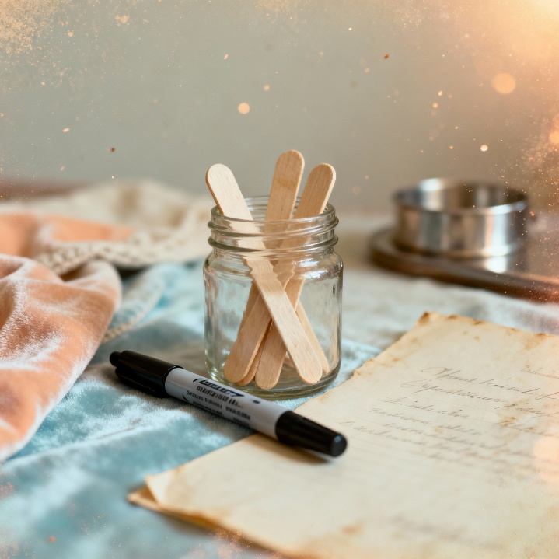
Links to NQS and EYLF:
NQS – Quality Area 5: Relationships with children
Singing together builds a sense of belonging, strengthens relationships, and encourages positive group interactions.

EYLF – Outcome 1: Children have a strong sense of identity
Children develop confidence and a sense of belonging as they participate in group singing and movement.

Notes:
The pop sticks do not need to just have nursery rhymes on them, they can also have actions for the children to do, so that they can have a movement break.
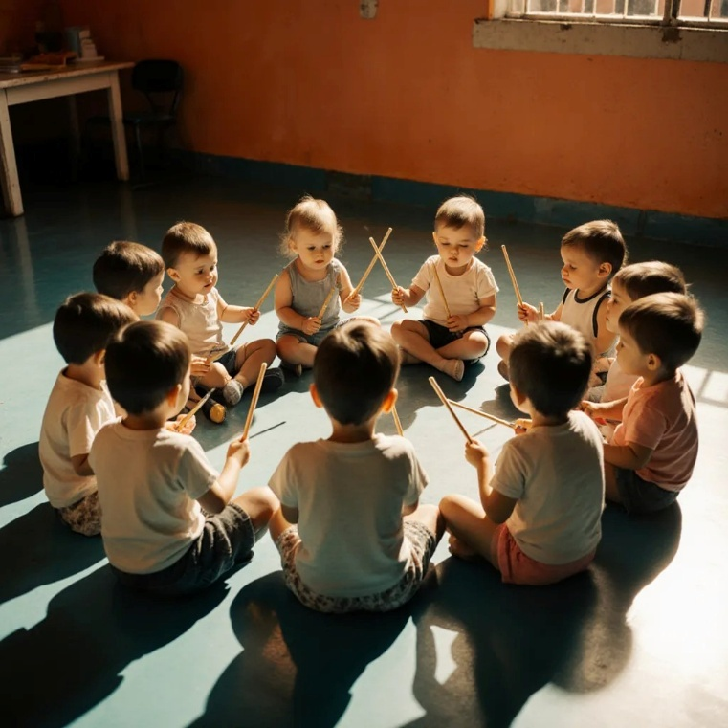
Links to NQS and EYLF:
NQS – Quality Area 2: Children’s health and safety
Rhythmic clapping and tapping supports self-regulation, focus, and emotional interaction.

EYLF – Outcome 3: Children have a strong sense of wellbeing
This experience supports self-regulation, coordination, and relaxation.

Notes:
To further extend on this experience, incorporate large body movement patterns into this experience.
Sound (auditory)
Clap and tap
Resources:
Quiet space indoor
Tapping sticks

Instructions:
Gather children in a circle or seated group.
Demonstrate a simple rhythm by clapping hands or tapping on the floor/table.
Encourage the children to listen closely and repeat it back.
Sight (visual)
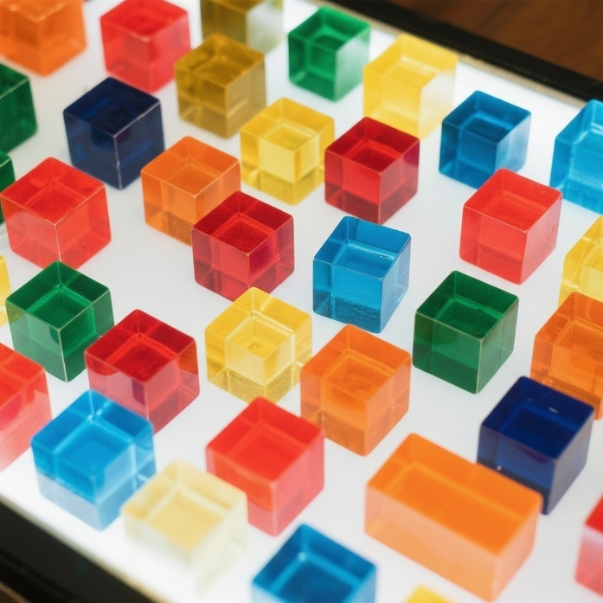
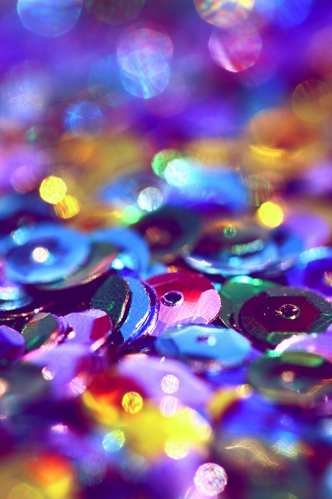
Links to NQS and EYLF:
NQS – Quality area 1: Educational program and practice
Light tables with blocks encourage open-ended, play-based learning through exploration of light, colour, and construction.

EYLF – Outcome 4: Children are confident and involved learners
By using the light table, children are encouraged to explore, problem-solve, and experiment with cause and effect through stacking, balancing, and colour mixing.

Light tables with blocks
Resources:
Light table (or light box)
Transparent or translucent blocks
Loose parts (optional)

Instructions:
Set up the light table with a range of translucent blocks and materials.
Invite children to build, stack, and arrange the blocks on the table.

Kaleidoscopes
Resources:
Empty paper towel rolls
Coloured cellophane
Beads
Sequins
Glue
Elastic bands

Instructions:
Put coloured cellophane over one end of the paper towel roll, leaving the other end open.
Seal the cellophane to the paper towel roll with glue and then an elastic band on the outside.
From the open end, pour sequins and beads into it.
Seal the open end with some more cellophane, glue and an elastic band.

Safety notes:
Before use, make sure the ends are secured so that no objects can fall into the children’s eyes.

Sight (visual)
Links to NQS and EYLF:
NQS – Quality Area 3: Physical environment
Kaleidoscopes provide a unique resource that promote sensory discovery and creativity. They can be used in calm down corners to help with regulation.

EYLF – Outcome 1: Children have a strong sense of identity
Children build confidence in expressing their ideas and interpretations of what they see.

Notes:
To further extend on this experience, incorporate large body movement patterns into this experience.
Sight (visual)

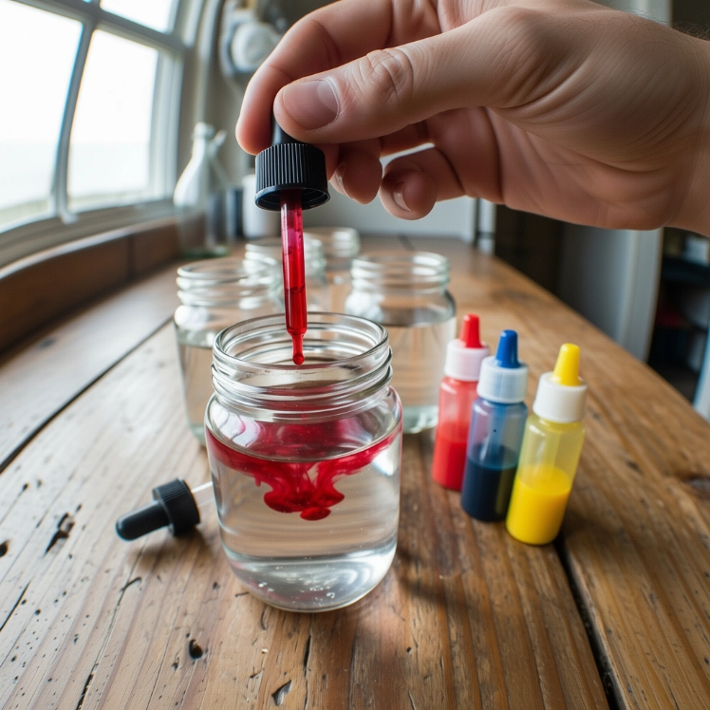
Links to NQS and EYLF:
NQS – Quality Area 3: Physical environment
The materials within this experience create an engaging and inviting environment for sensory exploration.

EYLF – Outcome 5: Children are effective communicators
Children use descriptive language to explain their colour choices predictions, and discoveries.

Colour mixing
Resources:
Clear cups or trays
Water
Food colouring (primary colours only)
Droppers, pipettes, or spoons

Instructions:
Fill cups or trays with water and add a few drops of different food colouring.
Provide children with droppers or spoons to mix the colours together.
Encourage the children to predict what colours will appear when the colours are mixed together.

Sight (visual)

Sensory bottles
Resources:
Clear plastic bottles with secure lids
Warm water
Glitter, sequins, beads or small objects
Clear glue or baby oil
Food colouring (optional)
Super glue or hot glue

Instructions:
Fill each bottle with a mix of water, glitter, sequins, or beads.
Add clear glue or baby oil to change the speed of how the objects move.
Secure the lid tightly with hot glue or super glue.

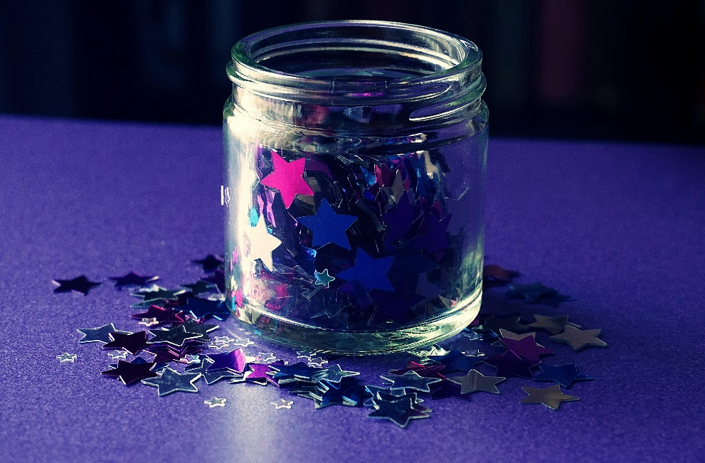

Notes:
Sensory bottles provide a soothing visual, and support children’s ability to focus and regulate emotions.

Links to NQS and EYLF:
NQS – Quality Area 1: Educational program and practice
Sensory bottles support play-based learning that encourages self-regulation, focus, and exploration.

EYLF – Outcome 4: Children are confident and involved learners
Children can explore cause and effect as they shake, turn, and watch how items in the bottle move.

Sight (visual)

Watch and copy movement games
Resources:
Open space
Music for added rhythm (optional)

Instructions:
Gather children in a circle or a group.
Demonstrate a simple movement such as clapping, jumping, spinning, or waving.
Encourage the children to mimic the movement back.
Continually add movements in, each round, dependent on children’s skill and developmental level.

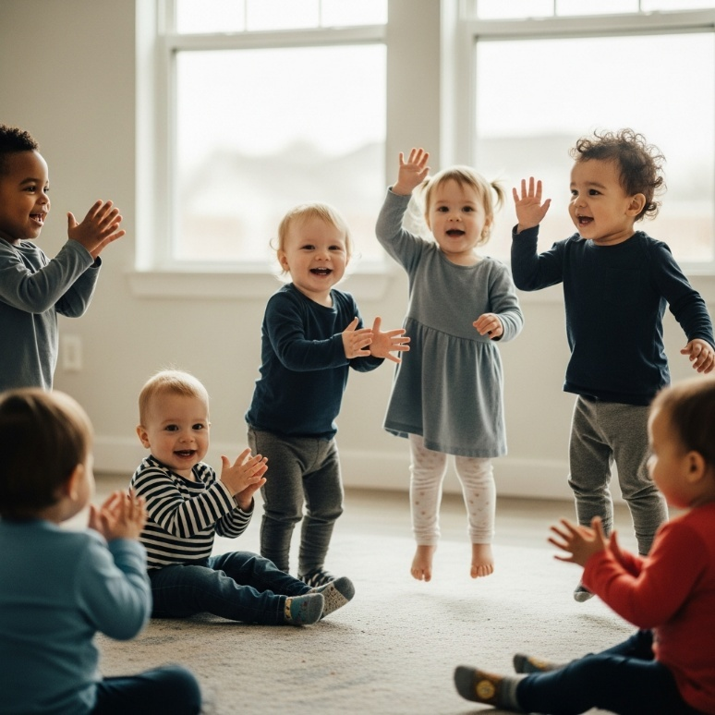

Links to NQS and EYLF:
NQS – Quality Area 1: Educational program and practice
Watch and copy games encourage active, play-based learning that supports physical and cognitive development.

EYLF – Outcome 3: Children have a strong sense of wellbeing:
Active movement strengthens physical health, coordination, and emotional regulation.

Sight (visual)

Mirror play
Resources:
Child-safe mirrors
Scarves, hats, dress-up items, emotion cards (optional)

Instructions:
Place the mirrors on the floor or on a table.
Bring a basket over and place the scarves and dress ups in them.
Stick emotion cards around the edges of the mirror.
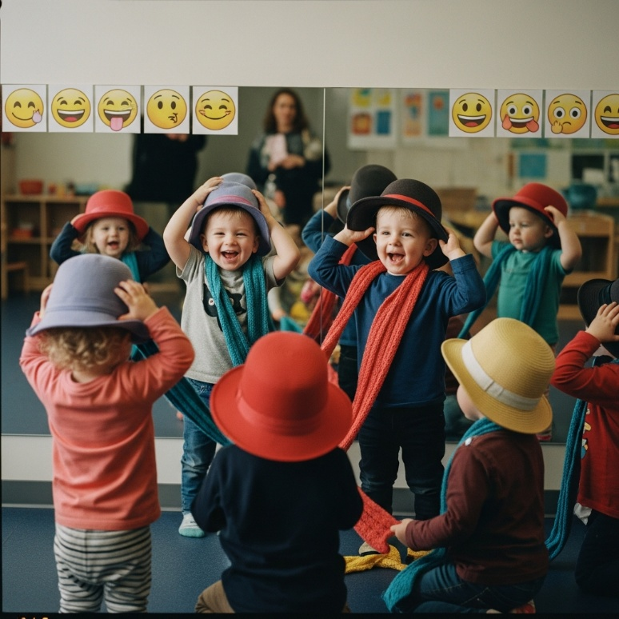

Links to NQS and EYLF:
NQS – Quality Area 1: Educational program and practice
Mirror play promotes open-ended learning through self-discovery.

EYLF – Outcome 3: Children have a strong sense of wellbeing
Exploring emotions through expressions supports self-regulation and emotional development.

Notes:
This experience encourages children to explore emotions, but also for younger children, it develops their recognition skills as they learn what they look like.
Smell (olfactory)

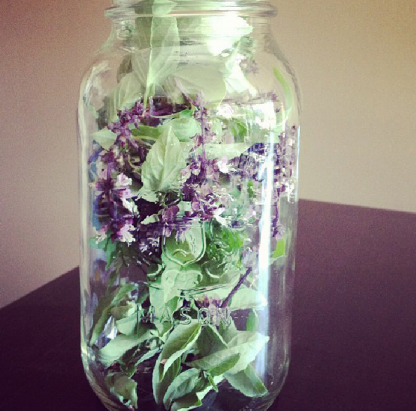
Links to NQS and EYLF:
NQS – Quality Area 3: Physical environment
Scent jars create and engaging, hands-on resource that supports curiosity within children.

EYLF – Outcome 4: Children are confident and involved learners
Children investigate, compare and demonstrate curiosity as they explore the different scents.

Smelling jars
Resources:
Small jars or containers with lids and small holes pierced in the top
Cotton balls
Variety of scents (e.g., vanilla, lemon, coffee, cinnamon, lavender, mint, herbs, spices)
Super glue or hot glue]

Instructions:
Place scented cotton balls, or scents inside each jar.
Seal the lids with hot glue or super glue and wait till it has dried.

Notes:
Scents can be rotated for different seasons i.e. use cinnamon at Christmas time to link to the smell of gingerbread.

Smell (olfactory)

Herbs and flowers sensory tray
Resources:
A large shallow tub or tray
Fresh or dried herbs (e.g. mint, rosemary, basil, lavender, thyme)
Fresh or dried flowers (e.g. rose petals, daisies, marigolds)
Small bowls, scoops, spoons, and jars

Instructions:
Arrange herbs and flowers in the tray in a way that children can touch, smell and explore them.
Encourage children to gently crush or rub the leaves to release the scents.

This experience also links to the sense of touch

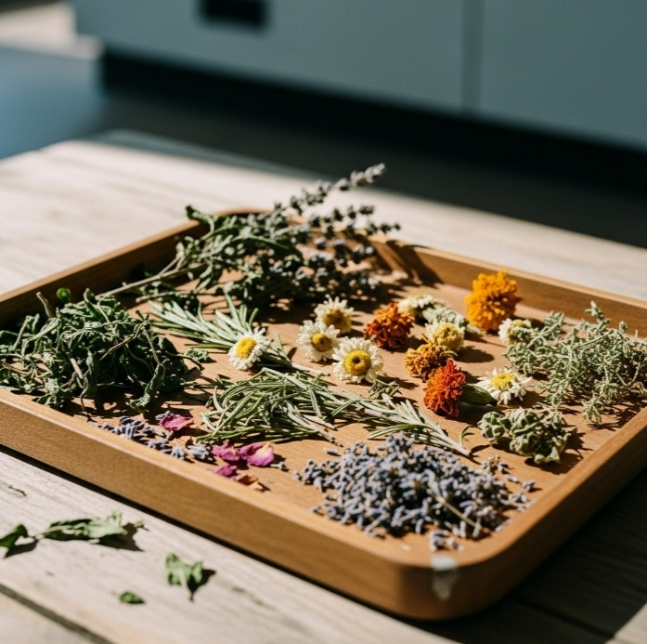
Links to NQS and EYLF:
NQS – Quality Area 6: Collaborative partnerships with families and communities
Families can contribute herbs and flowers from home.

EYLF – Outcome 2: Children are connected with and contribute to their world
Exploring natural resources helps children develop respect for the environment.

Smell (olfactory)

Scented paints
Resources:
Cornflour
Water
Food colouring (various colours)
Food flavourings (e.g. vanilla, peppermint essence)
Mixing bowls and spoons
Paintbrushes
Paper

Instructions:
Mix cornflour with a small amount of cold water to form a smooth paste.
Divide the mixture into small bowls.
Add food colouring to create different colours.
Add a few drops of food flavouring to each bowl for a unique scent.
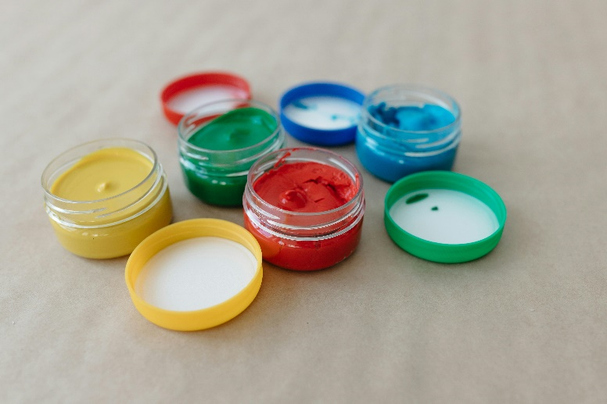

Safety notes:
If the consistency is off, you can use boiling water to thicken the mixture up. However, please ensure that this experience always promotes the safety of all children.

Links to NQS and EYLF:
NQS – Quality Area 3: Physical environment
The scented paints provide a creative, stimulating resource that supports multi-sensory learning.

EYLF – Outcome 4: Children are confident and involved learners
By engaging with the scented paints, children investigate cause and effect as they mix colours, experiment with textures, and notice scents.

This experience also links to the sense of touch.
Smell (olfactory)

Fabric soft scented toys
Resources:
Small fabric squares of soft materials
Needle and thread or sewing machine
Filling materials (rice, lentils or dried beans)
Scents to add (dried lavender, cinnamon, drops of child-safe essential oils)

Instructions:
Sew fabric squares into small bean bag style toys, leave a small opening.
Fill each toy with rice, lentils or beans.
Add dried herbs, or a few drops of essential oil.
Sew the opening closed securely.

This experience also links to the sense of touch

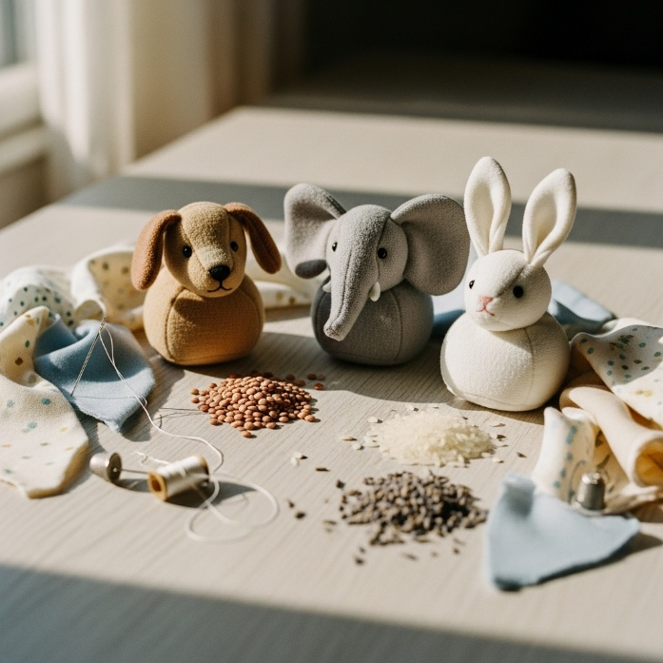
Links to NQS and EYLF:
NQS- Quality Area 2: Children’s health and safety
Educators ensure that they resources made are safe and that they support emotional regulation and sensory needs.

EYLF – Outcome 3: Children have a strong sense of wellbeing
Calming scents support relaxation, self-regulation, and emotional wellbeing.

Safety notes:
As this experience does require sewing, this experience will need to be made before implementing it inside your classroom.

Smell (olfactory)

Scented water
Resources:
Clean empty spray bottles
Water
Child-safe scents (e.g. food flavourings or child-safe essential oils)
Food colouring
Paper

Instructions:
Fill each spray bottle with water.
Add in a few drops of child-safe scents as well as a few drops of food colouring.
Offer the bottles to the children and encourage them to spray the scented water onto their paper.

This experience also links to the sense of touch

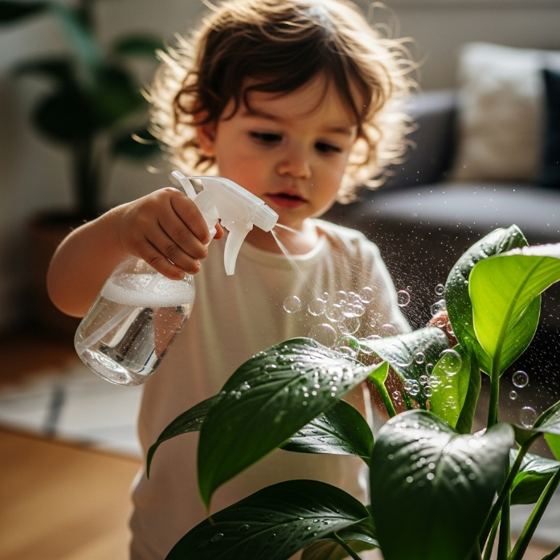
Links to NQS and EYLF:
NQS – Quality Area 1: Educational program and practice
This experience supports open-ended exploration and sensory learning through water play.

EYLF – Outcome 2: Children are connected with and contribute to their world
Children engage with natural scents and notice changes in their environment.

Notes:
To change the experience, instead of scented water, add dishwashing liquid to the water and encourage the children to spray objects and observe the bubbles.
Taste (gustatory)
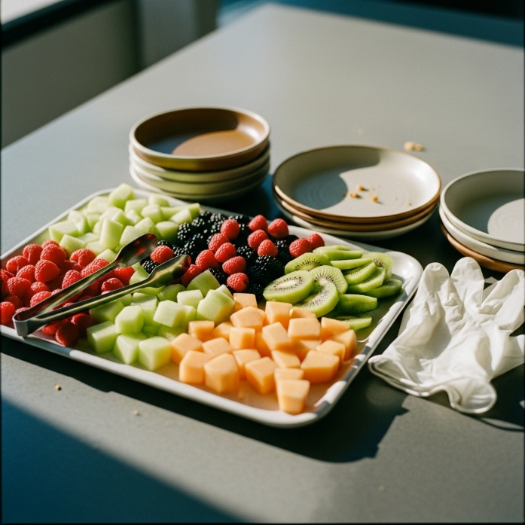
Food tasting
Resources:
Variety of allergy safe, bite sized fruits, with different textures and tastes
Small plates or bowls
Tongs or serving spoons
Gloves

Instructions:
Prepare small sample sizes of different foods.
Present the foods to the children one at a time for them to taste.
Links to NQS and EYLF:
NQS – Quality Area 1: Educational program and practice
Food tasting provides hands-on, sensory-based exploration that builds knowledge and vocabulary.

EYLF – Outcome 3: Children have a strong sense of wellbeing
Food tasting supports healthy lifestyles, by engaging children in exploring nutritious foods.

Safety Note:
To ensure this experience is safe and appropriate for the children, refer to R028 Food safety and Nutrition Policy and be mindful of allergies and dietary requirements when planning this experience.

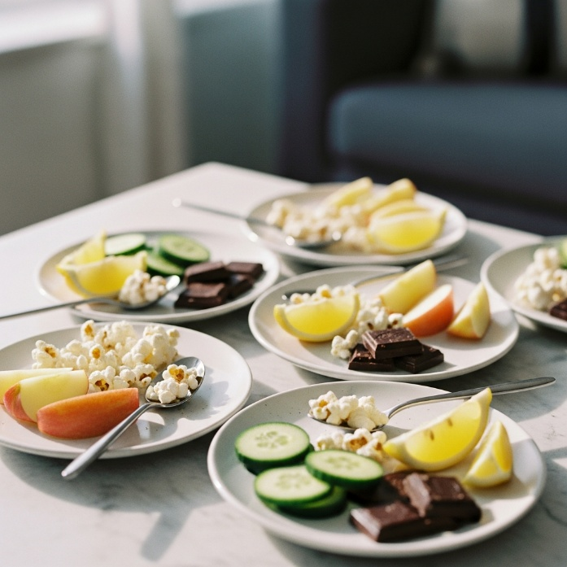
Taste test adventure
Resources:
A variety of safe, non-allergenic food with different flavours (sweet, sour, salty, bitter) e.g., apple slices, plain popcorn, lemon, cucumber, dark chocolate
Small bowls or plates
Spoons

Instructions:
Set up a table with the small samples of each food in separate bowls
Invite the children to take turns tasting the foods, one at a time.
Encourage them to describe what they can taste.
Safety Note:
To ensure this experience is safe and appropriate for the children, be mindful of allergies and dietary requirements when planning this experience.

Taste (gustatory)
Links to NQS and EYLF:
NQS – Quality Area 1: Educational program and practice
Taste testing encourages exploration and learning through sensory experience and language development.

EYLF – Outcome 4: Children are confident and involved learners
Taste testing encourages investigation, curiosity, and comparison through tasting and describing.

Notes:
Between each tasting encourage the children to have a drink of water.
Movement & balance (vestibular)

Balance beams
Resources:
Low wooden beams
Tape or chalk (as an alternative to wooden beams)
Soft mats

Instructions:
Set up balance beams or taped lines on a flat surface.
If using balance beams, ensure safety mats are placed down in appropriate areas.
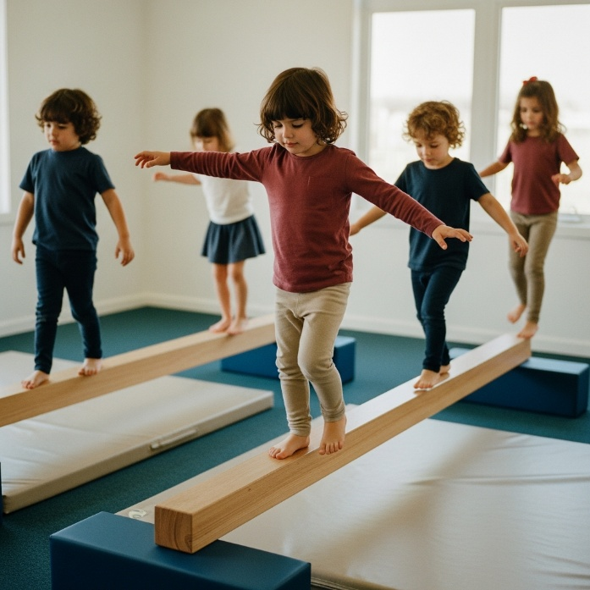
Links to NQS and EYLF:
NQS – Quality Area 1: Educational program and practice
Balance beams encourage active, play-based learning that promotes physical development.

EYLF – Outcome 3: Children have a strong sense of wellbeing
Balance beam experiences, strengthen gross motor skills, balance, coordination and self-regulation.

Safety Note:
When engaging in the set-up of this experience please refer to R025 Child Safety and Wellbeing Policy, R023 Physical Environment Policy and R015 Supervision of Children Policy, to ensure the set-up of this experience aligns with all relevant policies.

Notes:
To further extend on this experience, once the children have demonstrated confidence and competence in walking along the balance beams, encourage them to walk backwards or sideways.
Movement & balance (vestibular)

Obstacle course
Resources:
Soft play equipment (mats, foam blocks)
Balance beams or planks
Hoops
Cones or chairs
Cushions

Instructions:
Set up an obstacle course with a mix of crawling, climbing, balancing, jumping, and rolling activities.
Guide the children through the course at their own pace.
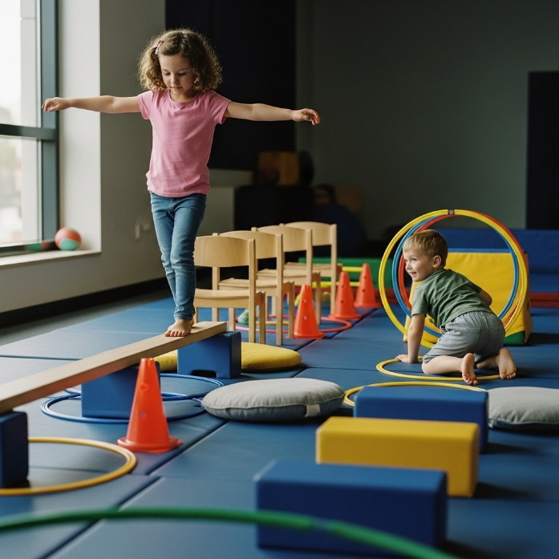

Notes:
To further extend on this experience, slowly introduce new obstacles, instead of setting them out all at once
Links to NQS and EYLF:
NQS – Quality Area 2: Children’s health and safety
Obstacle courses encourage safe risk-taking and movement in a supervised setting.

EYLF- Outcome 4: Children are confident and involved learners
This experience encourages problem-solving, risk assessment, and persistence through challenges.

Safety Note:
When engaging in the set-up of this experience please refer to R025 Child Safety and Wellbeing Policy, R023 Physical Environment Policy and R015 Supervision of Children Policy, to ensure the set-up of this experience aligns with all relevant policies.

Movement & balance (vestibular)

Dancing
Resources:
Speaker
Service approved device

Instructions:
Clear a space large enough for children and educators to move about freely with large body movements.
Set up the speaker nearby (be mindful of the volume level).
Using the service approved device, play some fun upbeat nursery rhymes for the children to dance to.
Encourage large body movements.
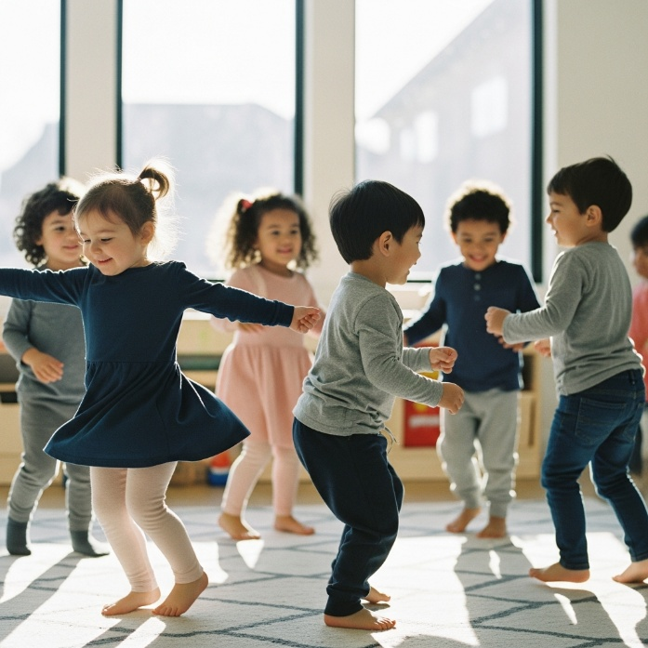

Links to NQS and EYLF:
NQS – Quality Area 3: Physical environment
Music and movement activities create a rich learning space that invites participation and exploration.

EYLF – Outcome 3: Children have a strong sense of wellbeing
Dancing supports emotional wellbeing and self-regulation through joyful movement while developing children’s physical skills such as balance, coordination, and stamina.

Notes:
Before engaging in this experience, take note of the children’s behaviours. If they are overwhelmed or overstimulated, instead of dancing with upbeat high tempo music, put on some relaxing music and have them lay down on the ground flat and listen to it.
Body Awareness
(proprioceptive)
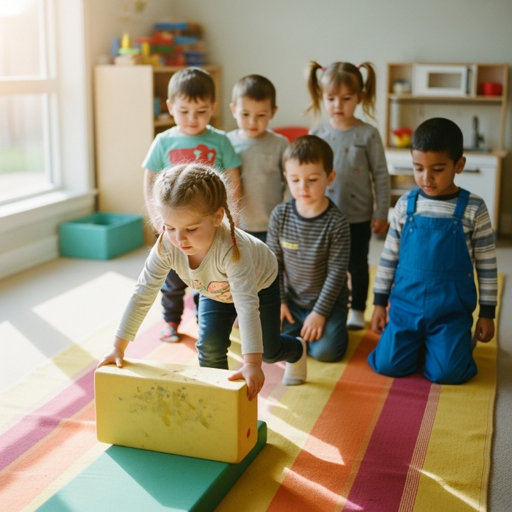
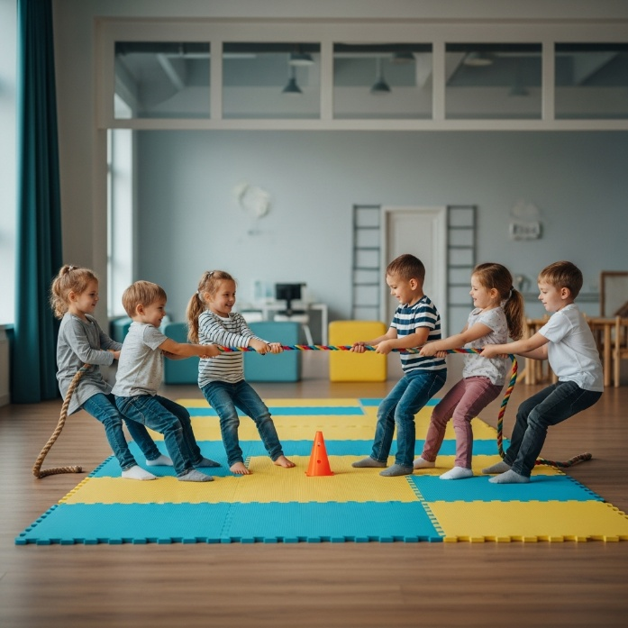
Links to NQS and EYLF:
NQS – Quality Area 1: Educational program and practice
Pushing heavy blocks supports physical learning that promotes body awareness and regulation.

EYLF – Outcome 3: Children have a strong sense of wellbeing
This experience develops strength, coordination, and regulation through whole-body movement.

Pushing heavy blocks
Resources:
Large foam or wooden blocks
Boxes filled with safe, heavy items (blankets, soft toys, sandbags)
Clear floor space indoors or outdoors

Instructions:
Set up the blocks or boxes on one end of an environment or mat.
Gather the children around and demonstrate how to push the blocks and the boxes.
Notes:
To further extend on this experience, add in obstacles to encourage the children to change directions and go around them.
Safety Note:
Ensure the blocks and boxes are heavy enough to provide resistance but not too heavy for the children to move them.

Tug of war
Resources:
A strong thick rope
Soft mats or grass area
Cones

Instructions:
Divide the children into two groups.
Place a cone on the ground to mark out a halfway point.
Line the rope up with the halfway point.
On a signal, encourage the children on either side to pull the rope.
Safety Note:
Refer to R015 Supervision of Children.

Notes:
To make this experience more challenging and engaging. Switch it up and have the children verse the educators.
Body Awareness
(proprioceptive)
Links to NQS and EYLF:
NQS – Quality Area 1: Educational program and practice
Tug of war provides play-based learning that supports the physical development and teamwork.

EYLF – Outcome 1: Children have a strong sense of identity
Tug of war promotes confidence, resilience, and pride as children work with their team.

Body Awareness
(proprioceptive)

Regulating breathing exercises
Resources:
Speaker
Service approved device
Yoga mats
Clear grass area

Instructions:
Set up yoga mats on the grass.
Play some soft, soothing instrumental music on the service-approved device.
If children do not want to lay on the yoga mats encourage them to sit or laydown on the grass.
As the children are laying down or sitting, in a soft voice, talk about deep breathing. Encourage them to take slow deep breaths in and out.
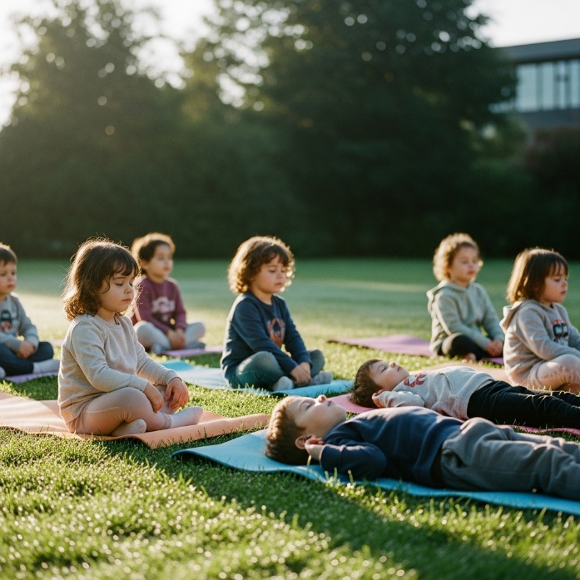
Links to NQS and EYLF:
NQS- Quality area 1: Educational program and practice
Regulating breathing exercises provides intentional teaching that supports children’s social and emotional learning and self-regulation.
EYLF – Outcome 3: Children have a strong sense of wellbeing
Regulated beathing exercises directly supports physical and emotional wellbeing through breathing, relation, and mindfulness.

Notes:
If a child is demonstrating heightened emotions or is overwhelmed, don’t use any music, invite them to listen to the noises around them.
- Australian Children’s Education & Care Quality Authority (ACECQA) – acecqa.gov.au
- ACECQA – The Early Years Learning Framework for Australia (EYLF V2.0) – acecqa.gov.au
- Remida Perth (WA) - remida.com
- Rasing Children Network – raisingchildren.net.au
- Early Childhood Australia – learninghub.earlychildhoodaustralia.org.au
- Aussie Childcare Network – aussiechildcarenetwork.com.au
- Royalty Free images – pexels.com and vecteezy.com
Sources

